Ivor Memoirs 11.03.2020.
This document is bound to be regarded as egotistic but is intended as a record of my life and what influences affected how I lived and is written at the age of 72 in the belief that I am still relatively sane and fit.
1947 -1956
I was born on 16th November 1947 in Pontypool South Wales as part of the post war baby boom. My parents both originated from Sherborne in Dorset though some of dad’s relatives also came from Brendon and Exmoor country. During the war dad worked on production of munitions at Holton Heath near Poole and mum taught at a school in Wimborne Minster. My elder brother Arthur was born on 10th August 1945 while they were still in Parkstone near Poole.
In 1946 dad found a new job with British Nylon Spinners setting up a new factory near Pontypool in South Wales and they moved to an estate of prefab houses near New Inn which had been recently built to house post war workers and bring new industry to the area. Apparently 1947 was one of the worst winters on record though I was unaware of this at the time.
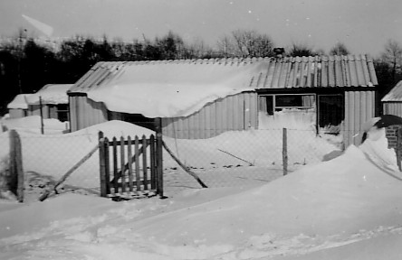 | 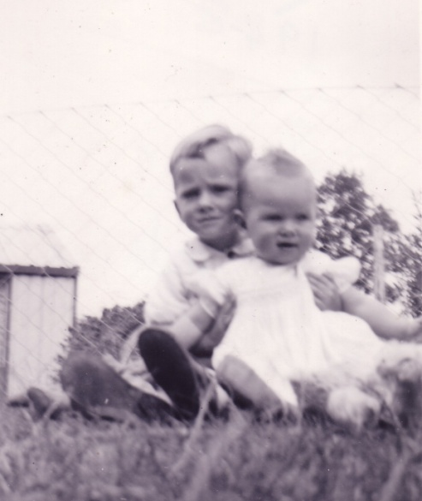
Prefab Winter 1947 from Caroline Road | Early picture of Arthur and me

My earliest memories were of playing in the garden at 49 Caroline Road where we had a pet tortoise and a black cat called Golly. We had a number of friends who lived in the same estate with Andrew Collins and Gaynor Hughes living directly opposite and Kay Mills just up the road. Kay’s parents were one of the first to have television and I felt lucky to be invited round to watch Andy Pandy and the Flower Pot Men. We also saw the coronation on TV.
I also remember rationing from early shopping trips on the back of mums push bike to Elmore’s the butchers, Wixey’s the grocers and the Co-op in New Inn. Drinks were still delivered by horse and cart door to door and I loved to scrounge an early ride up the road from our house. More serious shopping at weekends was in Pontypool which had a fresh fish stall run by Megan and Lottie and a general store which had an overhead wire conveyor for cash which always fascinated me, Dad also banked in Pontypool at an imposing Lloyds Bank where co-incidentally the manager was also called Mr Dibble
My first School was New Inn junior and infants school which was generally an enjoyable experience. This was in walking distance from home and our family doctor Dr. Dalby noticed me walking to school one morning. He contacted my parents concerned that I was walking “flat footed and bandy legged”. Not popular with mum and dad but where would you get that kind of care now. A series of exercises were recommended and seem to right the problem though I still walk with a slight spring in my step as a result.
A friendly pillow fight with my brother ended up with me at Pontypool Hospital at the age of 7 with a broken right collar bone. A later more serious fight with my brother, when I kicked him in the groin ended up with him in hospital and me in the dog house which has led me to be far more cautious from lashing out ever since.
My Primary School days were at the newly built Green Lawn School which I thoroughly enjoyed with many friends and generally enthusiastic teachers including Miss Holmes and Miss Baber. The head, Mr Hayward was a strict Churchillian character but I thought he was fine and ended up serving at his table during school diners. The only unpleasant memory of Green Lawn was when the grass was cut leaving piles of cuttings for break-time grass fights. I found for the first time that I was prone to hay-fever and was sent home with swollen itching eyes and cold-like symptoms.
Holidays during my early days usually combined a trip down to visit Gran (mum’s mum) in North Wooton near Sherborne and onward to Lulworth and Durdle Door caravan site on the Dorset south coast. Dad was always a car enthusiast first running an MG Magnet and later a 1937 drop head AC. The trip always involved the Severn crossing by ferry as the bridge was still a thing of the future
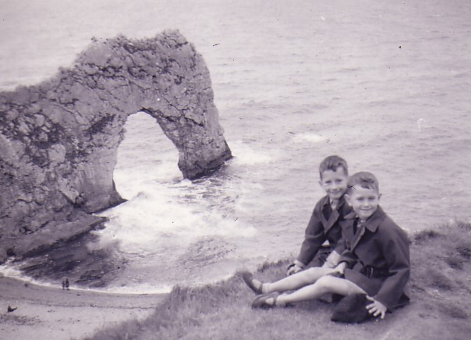 | 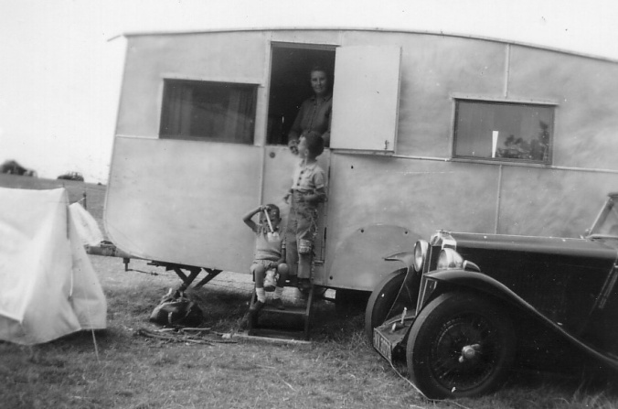
Arthur and me at Durdle Door below the camp site | The camp site at Durdle Door with the front of the MG just visible
The holidays were a great treat with swimming out to the Man-O War rock when weather permitted, plenty of rock pools, fresh mushrooms growing on the chalk downs and glow worms at night on the banks above the cliffs all adding fun to a simple holiday experience
The visit to Gran’s was also enjoyable as the area had been my parents childhood home territory. Mum had a great knowledge of plants and finding rare plants such as Butterfly Orchids growing locally and Bee Orchids at Badbury Rings, an old fortification near Poole, added a sense of discovery. Mum’s younger brother Uncle Fred and wife Aunty Mavis also lived with Gran. Fred had lied about his age and joined the army at 15yrs old in 1940. Mavis had been part of a Dance Hall group and they met during the war. This didn’t greatly appeal to my more academic and conservative minded parents both of whom had been schooled in Sherborne but as children my brother and I found them far more entertaining. They also provided support and care for my gran and her frail sister Aunt Nora.
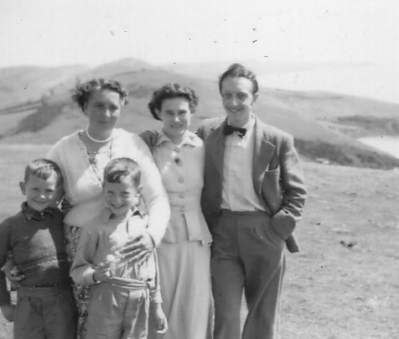 | 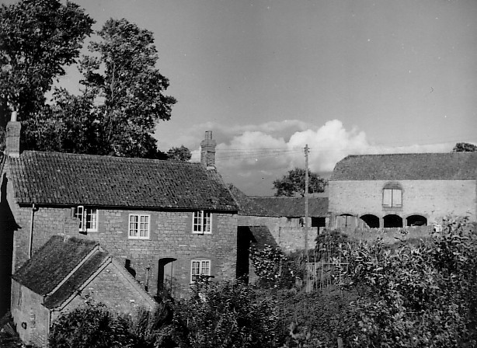
Mum, Mavis, Fred, Arthur and me. | Gran’s home at North Wooton

The other holidays I enjoyed were with dad’s uncle who lived in Brendon in Exmoor. Uncle George (Richards) was part of dad’s mum’s side of the family and he had married Denie Birge, daughter of the local farmers who owned Watersmeet Farm which figures in the R.D. Blackmore novel Lorna Doone. Their house named ”The Glebe” was accessed via a bridge over the Rive Lyn which was constantly guarded by two elegant mandarin geese. The farm owned Exmoor ponies which provided summer rides for tourists up the Doone valley but off season my brother and I had free rides exercising the ponies. Other distant cousins George and Herbert lived locally and we once played a version of cricket with them in a local field. Dad’s cousin Brenda also lived at the village Post Office and elderly Aunt Beattie lived next door. Known for her love of “Worts” which she picked on the local hillside, these with a generous helping of thick yellow cream straight from the farm was a great treat
We lived at the prefab in New Inn until I was nearly 9. I learned to ride a bike around the estate and also remember regular rides cutting through the local woods to Pontypool Road Station. At that time it was a thriving station both for goods and passengers and was one of the longest platforms in the country. Steam trains were the norm with large amounts of coal and goods trucks being shunted by smaller engines from the mining valleys. The Newport to Brecon Canal also ran nearby and a Pilkington’s glass works provided more employment near the station.
One of the last memories of my time in New Inn was being attacked by another school boy Kenneth Fry near a bus stop. He was shorter but broader than me and I was never clear what provoked the attack although I did have a slight West Country accent in a predominantly Welsh area. The outcome was that I lost the top of one of my new front teeth and have had to live with this as a capped tooth all my adult life.
1956 -1966
In 1956 Dad and Mum bought their first and only house in (Goetre) Penperlleni, a countryside area approx. 6 miles west of Abergavenny but only 2 miles from the British Nylon Spinners factory. This meant a bus trip to and from school in New Inn for me changing buses from the Abergavenny–Pontypool service to a local bus into New Inn. Arthur had just started secondary school at Abersychan Grammar School so changed in Pontypool for a local bus to Abersychan. This was quite a change in our lives as schools had been within walking distance prior to the move.
The countryside around our new home was a great asset for us as children with fields immediately accessible from the garden and nearby Forestry Commission land providing plenty of space to roam and explore. The house also had ¾ acre of garden with mature apple trees, a large Horse Chestnut, a small stream on the boundary and several sheds and outbuildings. Shortly after our move dad said he had to collect a parcel from Pontypool Road Station. This turned out to be one of the happiest days of my life as the large box he brought back turned out to be a Russell Terrier pup which we named Skipper who became our constant companion on walks and weekend rambles and was part of our lives for over 10 years.
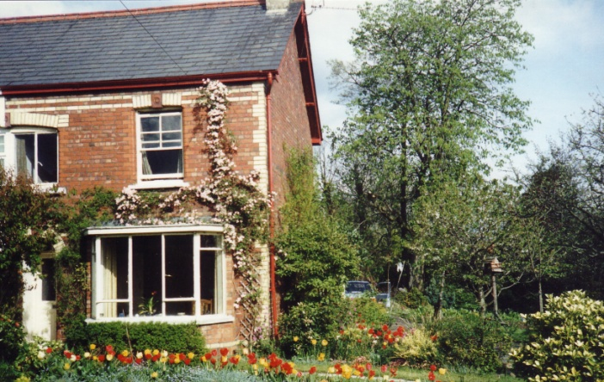 | 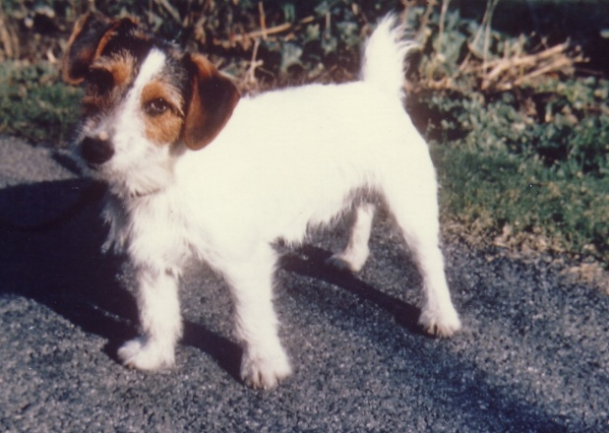
The house at Penperlleni | Skipper
An agreement with my parents was that we would help out in maintaining the garden and far from being a chore I found plenty of the work entertaining including cutting up wood, clearing out old tree stumps, rebuilding embankments to the stream, burning up rubbish and looking after my own small veg. Plot. Mums knowledge of plants and trees naturally stimulated my interest. She became an active member of NAFAS the National Association of Flower Arrangers and grew many plants to support that interest. There was a slightly snobby social side to this as Mrs Peter Thorneycroft, wife of the local MP was a keen member but mum led and taught many of the local neighbours and some weekends revolved around flower festivals in local churches with dad being roped in to collect and deliver large quantities of flowers and containers as mum didn’t drive. Many of the plants I still grow originally came from my parent’s garden and knowledge of trees and plants was gained from this time.
Weekends often involved drives into the surrounding countryside in a time when roads were still not crowded and driving was still a pleasure. This covered the Forest of Dean, Wye Valley and Brecon Beacons as well as more local beauty spots. When Gran came up to stay her birthday treat (25th October) was a drive through the Wye Valley past Tintern Abbey when the leaves were turning colour and back via Chepstow with its scenic castle.
A great asset from dad’s job at British Nylon Spinner was their staff sports and social club which provided facilities for all staff family members. This included a rifle range with training and arranged competitions with the ATS and other local clubs, a judo club with tuition from a black belt (Dennis East), several table tennis tables and a number of hard court tennis courts. This facility was only a few miles from home and an easy bike ride away barring Pentwyn Pitch, a steep hill climb on the return journey. Both Arthur and I made good use of the club and although we did not excel in any sport became modestly proficient in each.
For my secondary school years I followed Arthur to Abersychan Grammar Technical School, which was a combination of 2 schools offering both normal academic subjects and more practical subjects such as metalwork and technical drawing. The school generally provided excellent educational opportunities though it was obvious from an early stage that I wasn’t going to follow in dad’s footsteps with chemistry and the Welsh bias on history involving Owen Glyndwr and the like didn’t stimulate my enthusiasm.
I had lessons from a local piano teacher (Charley Merrick) who lived a few doors away from us in Goetre and later on from our school music teacher (Pete Sidaway) who lived in a new house on an estate built in the adjoining field to our house. Although not talented I became proficient on the keyboard and I took and passed O Level music and Art a year early at school allowing me to take a further 8 subjects at O Level the following year, all of which I passed with the exception of Latin which I re-took and passed again in the following term.
School sport was a bit of a mixed bag. I enjoyed cross country running and tennis but the PE teacher, one of life’s bullies thought I should be more interested in Rugby. Rivalry with the nearby West Monmouth Boys School team led to further confrontation on the bus trip home via Pontypool and I soon lost any remaining interest in a game which attracted such rivalry. Football was regarded as much of a lesser sport at Abersychan and I therefore never developed any interest in this as a teenager.
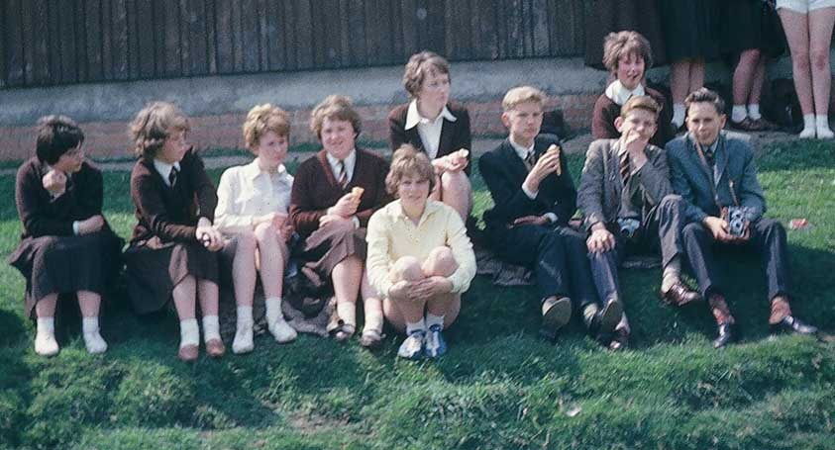 | 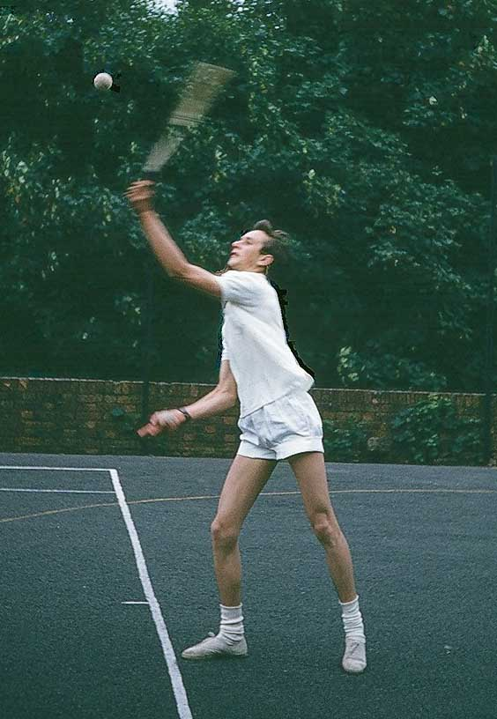
1962. Jaqueline Jeffries, Muriel Barr, Mary Gould, Susan Miles, Yvonne Herbert, Maureen Turnbull, Derek Hobbs, Nigel Stewart and me | Me school tennis match  1964
My strongest subjects included maths and art and thanks to support both from my art teacher (Mrs Brearley) and my parents I was able to continue with these through to A Level even gaining the school arts prize for several years presented by former pupil Roy Jenkins MP. I generally enjoyed my school years and had some good friends including David Hutchins, Derek Hobbs, John Jones, Nigel Stewart, Dai (David) Smith, Michael Phillips, Yvonne Herbert, Mary Gould, Maureen Turnbull and Gill Domini.
The combination of art and maths led me to an interest in architecture and the wealth of local castles on the Welsh borders and old fortified manor houses such as Tretower Court and Stokesay reinforced that interest. Another lucky co-incidence was the start of construction of the first Severn suspension bridge. A work colleague of dad’s, Colin Adams was related to John Cowerd who was chief architect in Cardiff advising on the materials and aesthetics of elements relating to the bridge although the construction was necessarily an engineer’s domain. This enabled me to get a close up visit to the bridge tower on the north side of the Severn as well as the adjoining smaller bridge over the mouth of the River Wye. The technical solutions involved in fabrication of sections for the bridge deck, floated down the Wye and hoisted up onto the newly spun suspension cables, with timing to suit “slack water” on both tidal rivers fascinated me.
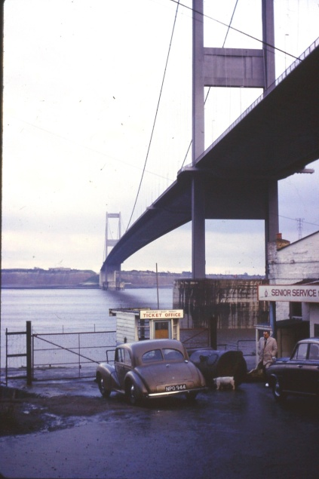 | 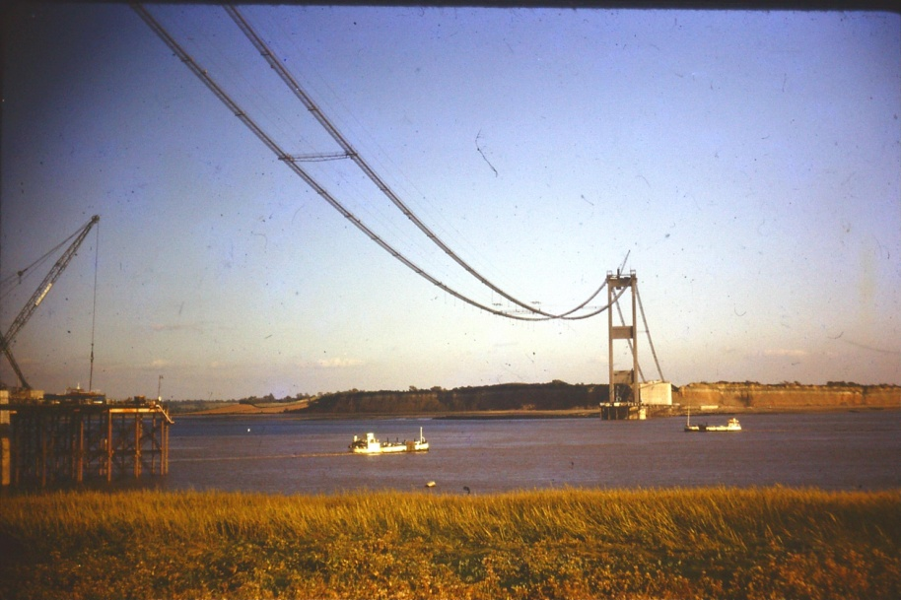

By the time of A Levels I had set my mind on a career in architecture. I completely messed up my A level physics exam but with A levels in Art and Pure and Applied Maths I managed to gain a place at Manchester Polytechnic School of Architecture on a 6 year RIBA course which included 2 years office experience and in September 1966 left home for a new life in Manchester.
1966-1973 College Days
During the first year at college students were required to live in approved digs. I was allocated a room in a house in Northenden along with another architectural student, Brian Priestley, son of a Huddersfield based woolen mill owner. Brian had lost his mum during his childhood and had been sent to public school for his secondary education. I was initially apprehensive about sharing with someone from a very different background but we oddly got on well enough and were glad of the company. Our lodgings were in a room belonging to an elderly couple Mr and Mrs Bunn who thought we should go to church on Sundays and never go out at night. Otherwise they were reasonable “landlords” but Mr Bunn chain smoked in the house. One day I opened the bedroom window to get some fresh air only to be told that Mr Bunn had painted them up closed for security so after only 2 terms we were asked to leave and find other accommodation. The new college approved digs was in Heaton Chapel near Stockport which was dirty and the quality of the food was dreadful so by the end of the year I started looking for independent accommodation near Manchester.
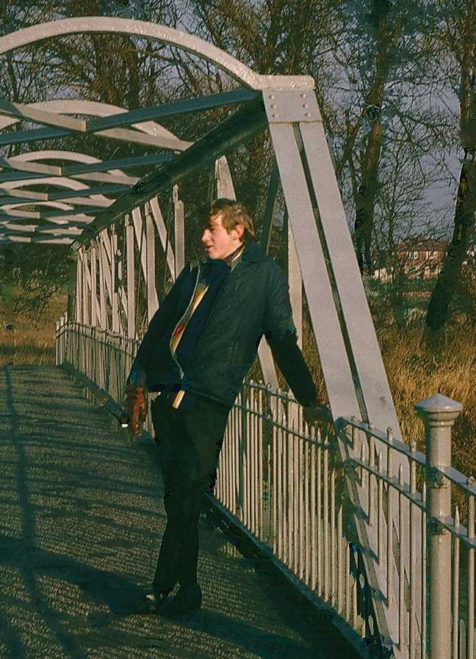 | 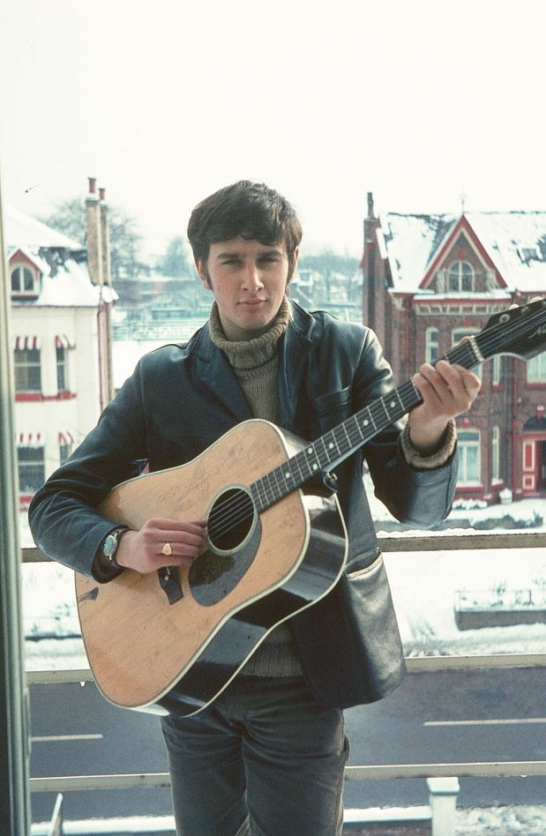
Brian Priestley on bridge over the Mersey at Northenden.1966 | Me on balcony to flat at Palatine Road  Didsbury 1969

Brian decided to buy a house with another student, John Lea but my pockets were not deep enough so I teamed up with 2 other students on the same course, Tony Babington and Bob Lloyd and took a up rooms in a house on Burton Road in Didsbury owned by a Polish landlord Mr Kuler. I ended up doing most of the cooking as I had been brought up to be able to cook most things. Tony, who was a direct descendant of Anthony Babington, subject of the Babington plot came from Londonderry and became a lifetime friend. Bob was the youngest son of the owners of a large hotel down in St Davids, Warpool Court, and eventually gave up the architectural course to help out in the family business.
Part of our college course was practical experience in an architect’s office for 18 months starting from mid-term in the second year. I was placed in the Manchester City Council’s housing office’ which, with hind sight, wasn’t the best background for broad experience involving a lot of prefabricated deck access high density buildings and also high rise flat blocks. I did however meet the first long term girl friend, a clerk with long red hair reminiscent of Boticcelli’s Venus called Judith Mason. This lasted for about 18months until I discovered she was also seeing a married man. All part of life’s rich experience!
Our college course also involved various trips including a trip to Cambridge and trips to Rotterdam and Bruges. These turned out to be great social events as well educational. While In 4th year at college I became a student representative for “Architrave” the architect’s branch of the student union. Shortly afterwards the Russian invasion of Prague resulted in a Czech architectural student Malada Lemanova becoming stranded on a visit to our college. She was very easy on the eye and I was happy to help arrange lodgings for her through my previous landlord Mr Kuler and enable her to join the course at college full time.
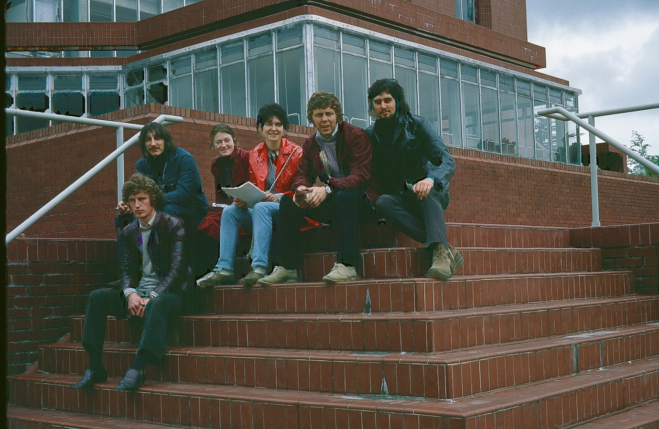
College trip to Cambridge calling at Leicester University on way.
Adrian Usher, Pete Carton, Denise Weadick, Malada Lemanova,Barry? and me

In 1969 Tony, through social contacts, found out that a student from Manchester University was looking for 2 other students to share a top floor flat in a house on Palatine Road in Didsbury overlooking the Northern Tennis Club and in the new Autumn term we joined our new flat mate Howard Dickinson at 121 Palatine Road. This was a great location with a direct bus route into college at All Saints and plenty of student hot spots in Didsbury and the surrounding area. The nearby Midland Pub on Lapwing Lane had regular Jazz Clubs with Alan Hare’s big band and Keith Pendlebury’s Zenith 6 providing regular entertainment within walking distance.
The Polytechnic also had a great entertainment network and in 4th year at college I became a student member of the architect’s social club “Architrave” helping to organise events and visiting lectures. One guest speaker of note was Denys Lasdun who went on to design the National Theatre in 1975. We also had visits from up and coming groups including Marc Bolan and Fleetwood Mac.
Howard came from a fairly wealthy family who owned a furniture store in Warrington and after 18 months at Palatine Road decided to move out and buy a separate flat. We found a replacement for him in another architectural student from the university Alan Kayley. Alan was a great social contact and lead to many new friends at the University as well as the Polytechnic. A regular weekend event was dances at Owens Park which attracted students from many colleges and courses. At one of these he met Jane Elliot a student from Elizabeth Gaskell teacher training college and they soon became inseparable. Co-incidentally Tony also met his future wife Jill from the same college.
I bought my first car, an old “notch backed” Ford Anglia in 1971 and tried to maintain it on the hard standing in front of the Palatine Road flat. One day in my old jeans and covered in grease under the car replacing a broken speedometer cable I noticed Jane Elliot calling around to see Alan in the company of one of her flat mates and was introduced to Gill Roberts. They both shared a flat with another student Moya Smiley on Lapwing Lane only 100 yards away. Shortly afterwards I was invited to a 21st birthday party at their flat and little did I realise at the time what this would lead to. Initially a few tentative dates with Gill and eventually a lasting life time relationship.
In summer 1971 Gill and I decided to take a holiday trip round Scotland. We borrowed Arthur’s frame tent and set out in the old Anglia making camp the first night in Glen Orchy. The heavens opened over night and the ground sheet of the tent lapped up with ground water but the next morning it cleared. We headed on for Glen Coe and the car ground to a halt on the pass. I eventually found a loose low tension lead and with the help of a match stick fixed the problem and we were on our way to Skye. The weather cleared and we had a further wonderful 10 days travelling up the west coast, across Kyle of Tongue and back down to Foyers on the south east side of Loch Ness.
The old notched back Anglia had served me well despite a side impact from another vehicle in the back streets of Didsbury while Alan Kayley was in the passenger seat. Both the other driver and I were insured with Vehicle and General which went into liquidation soon after the collision and I saw no money from the claim. Shortly afterwards I drove down to Yeovil in my battered vehicle to stay with Uncle Fred and Aunty Mavis. Fred saw the damage as a challenge and with the help of a car jack and chain wrapped round a railway sleeper we managed to pull the passenger door post straight and fit a new door from a local scrap yard
I found various part time jobs in architect’s offices during my student years, the most notable being Thomas Royal Associates in Stockport and Norman Bailey Samuels and Partners in Didsbury. I had hoped to continue with the latter once I had qualified but unfortunately it was a satellite office of a London based practice and in 1974 “Sammy” the main partner announced that he was closing the office. I qualified for my college degree in 1973 and had to do a year’s further office experience before taking my professional practice exams. At the same time we broke up the flat in Palatine Road and I temporarily moved into the house of a friend (Howard Robinson) in Heaton Mersey. I was aiming to buy the house but this eventually fell through as I could not find the finance.
During the time I was at Heaton Mersey I bought a second hand Ford Escort to replace the Anglia. Another college friend Graham Whiting had a contact, Vlasta, in Czechoslovakia from a previous work camp experience and amazingly he owned a post house at Usti near Prague. We came up with a plan to drive to Prague and stay with Vlasta for a week over summer. We also planned to visit Malada and family in Prague. Two days before we were due to go the new car burst into flames caused by a feed pipe blowing off the carburettor and discharging raw petrol over the engine and distributor. After replacing damaged engine mountings and a whole sheaf of wiring, the car was good as new.
We had a great week near Prague and the local people were incredibly friendly. Another advantage was that the car was white with yellow number plates and was mistaken by local police as a diplomatic car and was waved on in the streets of Prague which still bore the marks of the previous Dubcek troubles.
1973-1981 Move to Todmorden.
With no job available from my previous offices I made contact with City Architects in Manchester asking if they had any work that did not involve housing and managed to secure a job in their education team. Here I met Annie Horwood who worked in the city Planning Department. She was a catholic girl with incredible looks and figure and for a short time we became close friends. Her love of the club life and our lack of anything much in common however brought this to an end.
This job in City Architects was intended to be a short term arrangement but eventually lasted 16 years with offers of promotion each time I made a move to leave.
Initially the work was interesting but perversely the city had just resolved to build their first sheltered housing scheme and with my previous housing experience I was asked to take on the design of their initial project. This was successfully built by Fram Gerrards at Fellpark Road in Wythenshawe and named Alfred Morris Court after the local councillor and I subsequently ran another 3 projects based on the same design. This also became the standard adopted by the city for a further 16 sites though initially their Direct Works Department claimed the details we had built from were “inadequate”.
Over Christmas 1973 Gill’s brother Ken was tragically killed in an accident on the A9 at Pitlochry in Scotland. He had been a keen climber, climbing with experts such as Chris Bonnington. He was also a keen skier and had gone up to the Cairngorms for skiing over the Christmas break. He and a friend drove a Mini Moke full of all their equipment and camping gear but ran into an articulated lorry in the middle of the road beneath a railway bridge. This had a lasting and devastating effect on Gill and her parents. The Range Cottage at Altcar where they lived was remote and accessed via a bailey bridge over the River Alt and they eventually decided they had to leave and move into rented accommodation in Altcar.

For many years the work at City Architects was interesting and rewarding. Ron Smith my initial Group Leader was a good mentor and amazingly when he left he was replaced by Ray Smith who was equally good to work with and I was able to expand my experience with a wide range of educational buildings. In 1974 I moved out of the house in Heaton Mersey and temporarily moved into a house which Graham Whiting had bought in Smalldale Avenue in Moss Side. Not the most up-market area in Manchester but an interesting experience with cars cruising up the street at night looking for “company” and Maine Road, Manchester City’s football ground just up the road and attracting regular crowds of fans. Graham had a Doberman bitch called Zimbadu which helped with security but the lifestyle was not ideal.
Gill had found a job at Sale West Secondary School as a Home Economics teacher and we had been seeing a lot of each other but my accommodation was not ideal and I decided it was time to get on the housing market. After a fruitless search for affordable property south of Manchester a work colleague suggested I should look north of the city for cheaper housing and mentioned Tottington as being a possible place to look.
A quick look through the ads in the Manchester Evening News showed a terraced property for sale in Todmorden for just under £4K. Gill and I had been courting for some time and had looked at property around Congleton, Macclesfield and Sandbach all of which threw up prices in the order of £10K or more and we had been particularly envious of friends John and Christine Carter who had bought a black and white property on Astbury Green with a little help from a wealthy father-in-law. The £4K figure was far more realistic for my new salary so we drove up to Todmorden the same weekend and were delighted to find the property also had a double cellar and attic and a solid fuel Aga cooker in the kitchen. We made an immediate offer and soon became proud owners of our first property. Todmorden also had the advantage of a main rail link into Manchester which made commuting easier.
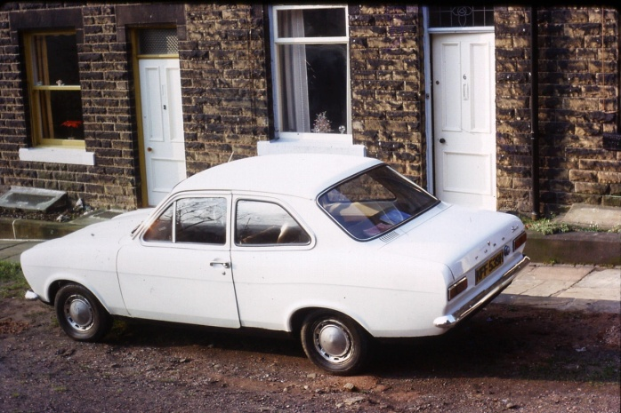 | 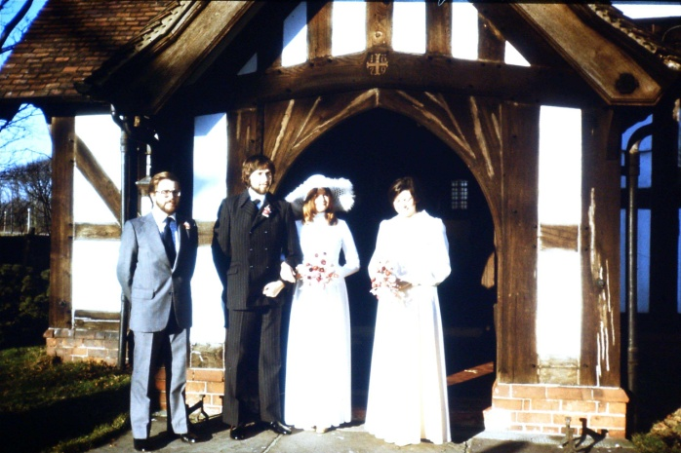
The Escort outside 6 Church Street | The wedding at Altcar Church with best man John Carter and Bridegroom Jane Kayley

In early 1975 Gill and I went for a walk up to Gibson Mill at Hardcastle Craggs and I decided it was time to “pop the question” as we got on well and were living together. Amazingly she said yes and we got engaged and planned for a wedding on 13th December. The weather was kind to us for the wedding and we arranged a honeymoon at Hammamet in Tunisia with a 2 night stop-over at a high class hotel in London prior to the flight from Gatwick. The weather turned much colder and de-icing the plane’s wings when we boarded at Gatwick did little for Gill’s nerves for her first flight but we made it and had a great 10 days in the sun before returning home for a family Christmas.
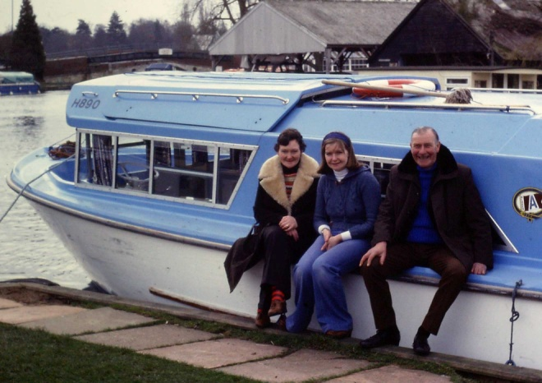  Gill, Mum and Dad on Broads  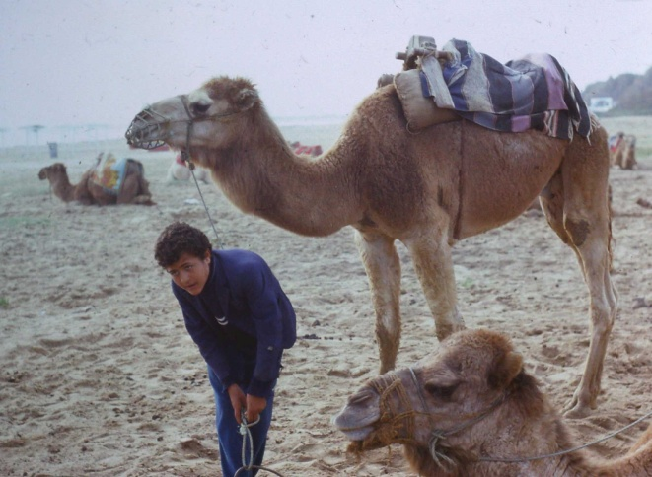 | 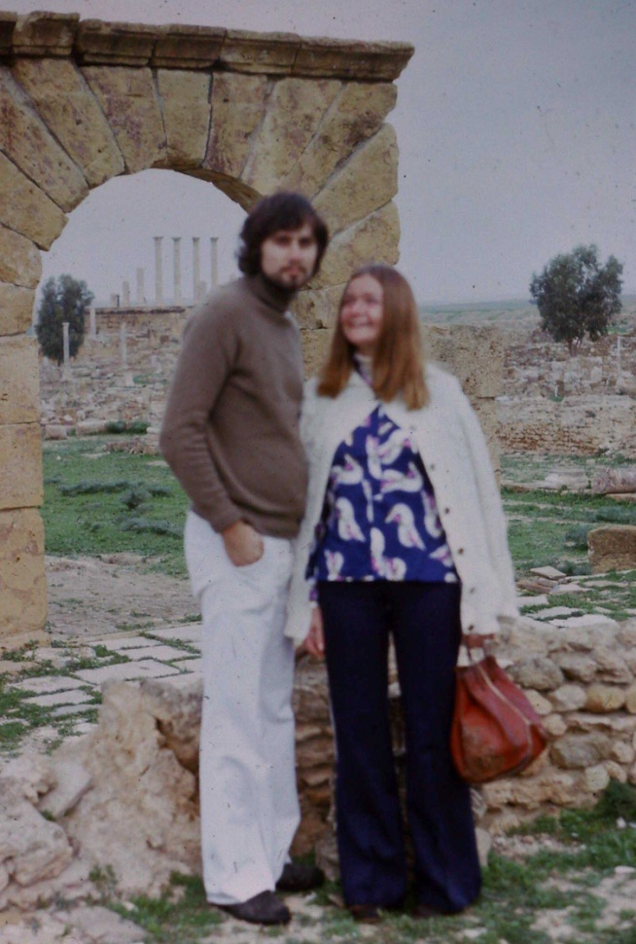
Camel Rides Hammamet | Gill and Me at ruins near Hammamet

Life at 6 Church Street Todmorden for the next 2 years settled into an enjoyable routine with Gill changing her job from Sale West to Hawthorns special needs school in Audenshawe. I traded in the old Ford Escort for a TVR Vixen. We also bought a Hillman Husky van to enable Gill to learn to drive. The van came from Ann Howarth who was a fellow teacher at Hawthorns who lived near Rochdale and often gave Gill lifts to work. We also had a great holiday with other college friends sharing a character cottage in Branscombe.
We also acquired a cat, Tiggy from the Hapton RSPCA. Our next door neighbour Lizzie Halstead, a spinster in he 80s became quite attached to Tiggy and often fed her tinned steak or tuna so that our offers of ordinary cat food were rejected on a regular basis.
In 1976 my old college friend Graham Whiting married a girl employed as clerk in City Architects called Anne Van den Bergen who had a mixed race daughter Rachel from a previous relationship. Graham therefore changed his name to Van den Bergen as he felt the name Whiting might cause problems. He also bought a house in Todmorden and called round regularly inviting us out for evening drinks. Unfortunately his habit of chain smoking “roll your own” cigarettes in Old Holborn paper spoiled the events and we were soon dodging the invites.
Early in 1978 we booked a boat on the broads for a holiday with Gill’s mum and dad, driving over in the old Husky van and had a great fortnight with them. We had also been looking at potential characterful properties in and around Todmorden to renovate and had put in offers on several. Among these were a cottage up above Jumble Hole near Hebden Bridge and a fire damaged cottage above Cornholme, both advertised by Crabtree’s Estate Agents. Later in the year Gill went to the doctors as she had been suffering from stomach pains. Initially the elderly Dr Grieve advised that he thought the cause was an ovarian cyst and surgery might be necessary. A second visit to another younger doctor Dr. Williams had a very different diagnosis concluding in the advice “congratulations Mrs Dibble you are pregnant”
This was great news but obviously needed a few changes in our life. Firstly the old Hillman Husky van had started to fume badly from the rear mounted engine and Gill had decided that driving was not for her so we decided to scrap it rather than waste money. Secondly the TVR, which had been fun for the past 3 years was not practical for a young family and we decided to sell it on. My big mistake was to be talked into buying a second hand Hillman Hunter from a friend of Graham Van den Bergen’s. The car was practical for a family man but had frequent problems with a sticking starter motor and I eventually found to my horror that it had been repaired from a crash write off.
On the same day that we found Gill was pregnant we called into Crabtree’s estate agents to see what progress had been made with any of the property offers and were advised that our cash offer on the semi-detached, fire damaged cottage (16 Woodcote) in Cornholme, had been the highest offer. We went back up to look at the cottage and despite the prospect of having our income reduced to only one salary decided to go ahead with the purchase.

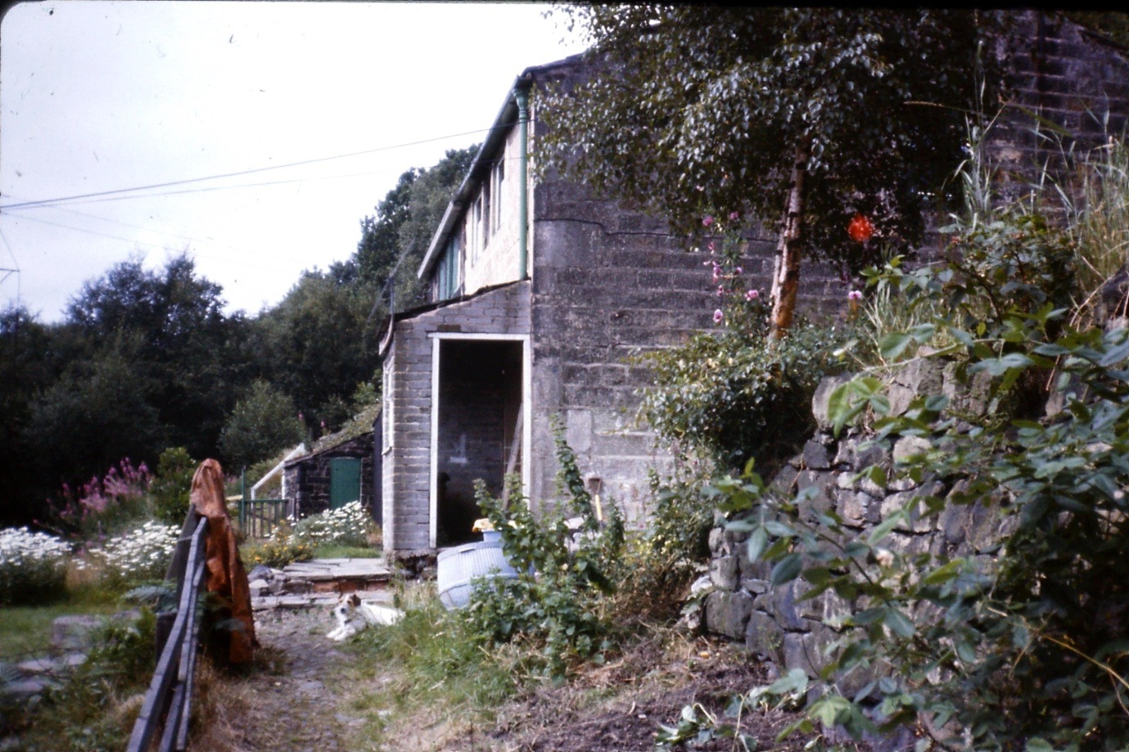 | 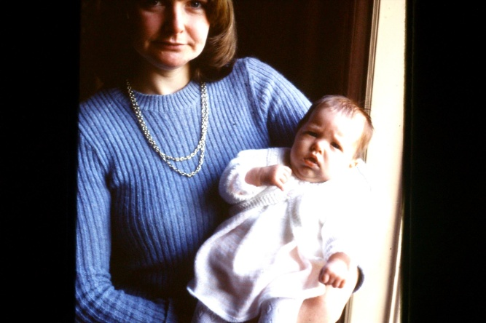
The cottage 1978 | Gill and Melissa 1978

On 5th September 1978 Melissa was born at Birch Hill Rochdale and thankfully all was well, even the Hillman Hunter started at the critical times for visits and to bring her home to Church Street and the next two years were involved in learning how to become parents and do up a fire damaged property at the same time. Gill’s parents were a great asset during this time and regularly came over to stay with us, with her mum (Peggy) helping Gill out while her dad (Ernie) came up to the cottage, helping clear debris, cart up materials and make copious mixes of mortar and also starting to sort out the overgrown hillside and garden.
The other half of the cottage was still inhabited by 96yr old Bertha Greenwood who as an ex. Mill girl was profoundly deaf but could lip read well. Often she would head out down the path to the adjacent Holme House Farm and on to the main road catching a bus to Todmorden. Later she would return with a bag of shopping and decline any offer of help saying she would only get lazy if she relied on others. Her younger sister Adelina lived in a cottage on the main road and often called up to visit saying that Bertha had always been a frail child.
We found that Gill was pregnant in early 1980 and on 13th June 1980 Marc was born at Burnley General Hospital. From then we were proud parents of both son and daughter

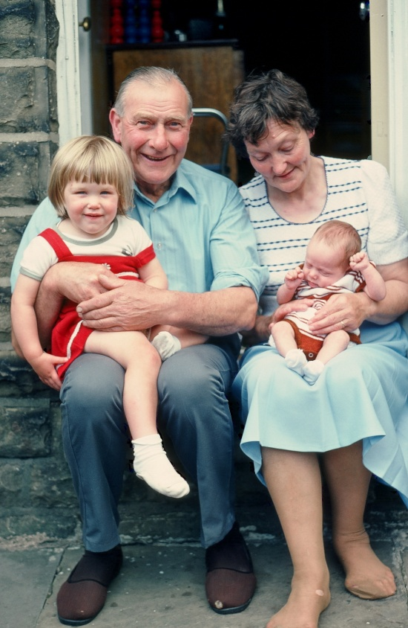 | 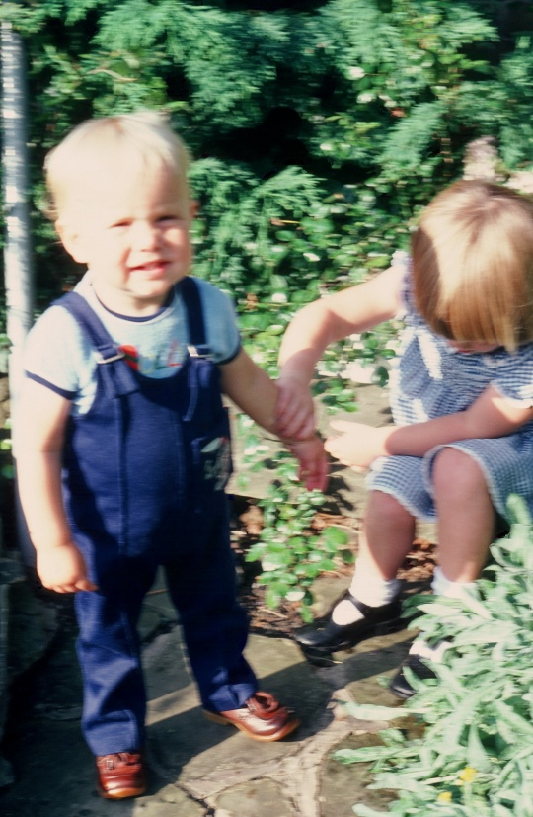
Gill’s mum and dad with children on doorstep at 6 Church Street | Marc and Melissa in garden at 6 Church Street.

Woodcote 1981-1989
With a growing family life at Church Street became much busier and help from Gill’s mum and dad both with child minding and work renovating the cottage was much appreciated. The other key event which affected our decisions then was that Mrs Greenwood the neighbour in the other half of Woodcote Cottages died at the age of 96 after a short illness and her cottage was put up for sale. This left us with a quandary as all of our ready capital had been spent on the mortgage at Church Street and initial cost for the cottage but buying the other half of Woodcote would effectively give us a detached property and a much bigger parcel of land extending down to Holme House Road. A chat with Lloyds Bank Manger eventually resulted in offer of a loan to buy the cottage if I could pay off the mortgage on Church Street.
Gill’s dad had retired from the TAs with a gratuity and agreed to use this to pay off the mortgage if they could move in to Church Street and live there for the rest of their lives. One item we had acquired when we bought the first half of Woodcote was a 4 birth caravan which had been craned onto the land at the time of the fire damage to house the previous owners. As Gill’s mum and dad were keen to leave their house at Altcar to free them from soaring rents they agreed to move into the caravan at Easter 1981 and store their furniture at Church Street while we got work done to link the two cottages and get these into a habitable condition. We hired a van and moved their furniture over on a beautiful warm Easter morning and set up the caravan with access to a workable bathroom and kitchen sink in the cottage. A week after they moved in the weather broke and over 1ft of snow fell at Woodcote.
By September 1981 the cottages were linked with a doorway at ground floor and central heating in the first half and we moved in so that Gill’s mum and dad could move to Church Street. Although there was still a lot to do on the cottages we managed with the help of grandparents to look after our young family and progress with renovation work. Gill’s dad also loved the challenge of the garden and his relocated greenhouse.
In November 1981 I also took the decision to get a large dog to help with security at the cottage and provide a family pet in addition to Tiggy the cat. Several years previously we had met friends John and Chris Carter in a pub called the Swettenham Arms near Goostrey and had been impressed by a Weimaranner dog which sat patiently at the bar with his master. Uncle Fred with his dog food business kept a look out for me and eventually found a couple whose bitch had had a litter down at Liphook near Southampton. After a phone conversation with the owner the following weekend we rented a car, packed in the children and drove down with cardboard box and cushion for the pup. The return journey home was entertaining as the box was demolished after the first few miles but with the children’s help we arrived home with Lance an 8 week old pup.
In 1982 we received a letter from North West Water advising that they required an easement to install new water mains across our land from Holme House Road up to a new holding tank on Shore Road above in order to serve some of the outlying properties. As they are a statutory undertaker I knew I could not oppose this work but rapidly concluded that it would be advantageous to obtain a mains supply as the cottages relied on a spring water supply. As their contractors would have to come up across our land I also approached them to see if we could extend the work to form a new driveway up to the cottages along with a new water main. I shook hands with Mr Mullen, their sub-contractor agreeing to a cash price of £1000 to put in the drive up to an area of land well below the house using the tarmac topping and granite setts excavated from the roads to a depth of 3ft thick as a base for the drive. This included a new water pipe and drainage across the drive but I agreed that I would hand dig the last 30m for the water main up to the cottages.

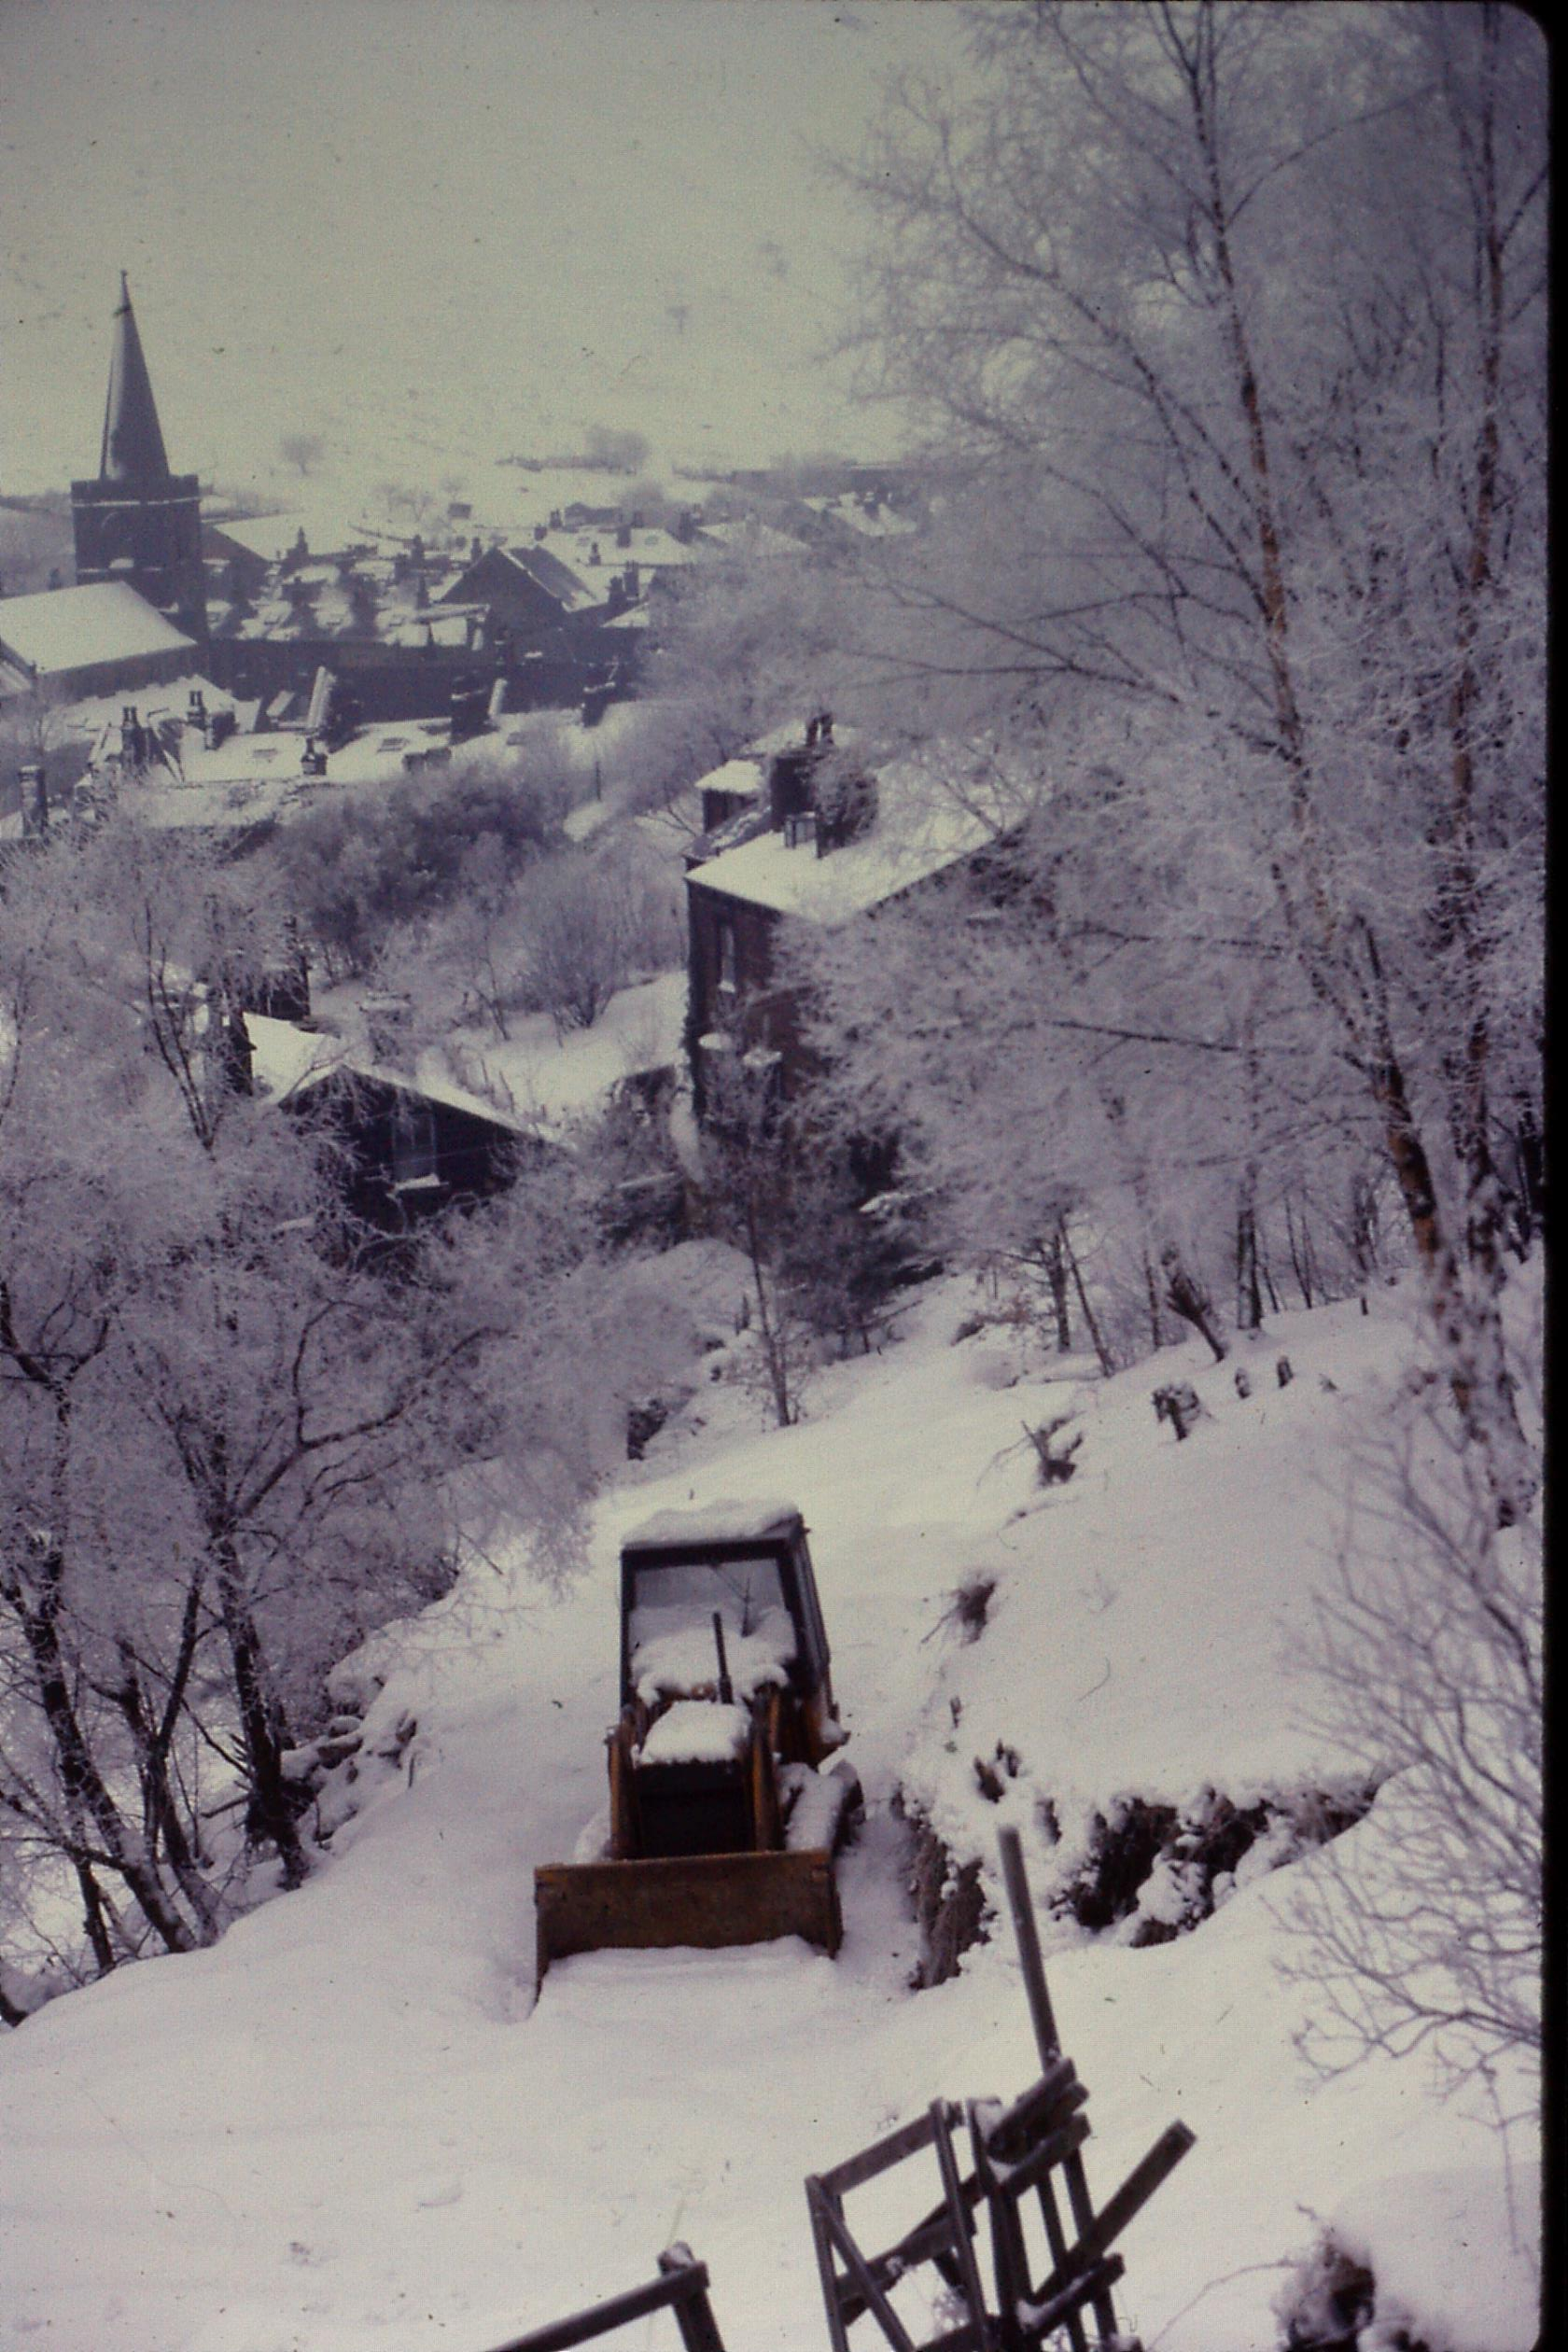 | 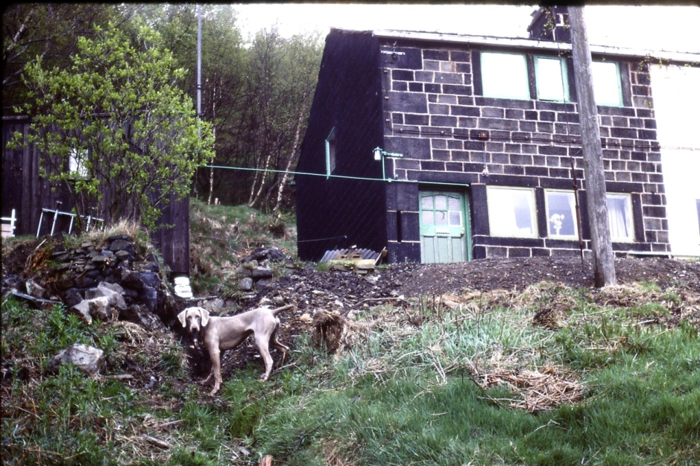
The drive in formation winter 1982 | Lance inspecting the water pipe trench.

In early 1982 I also decided to cut my losses and get rid of the Hillman Hunter for scrap. Through a friend who lived up on Badger Lane at Blackshawe Head and had an ex-army lightweight Landrover I found out about Dave Beaumont who re-built Landrovers and also serviced the Local Authority’s vehicles for a living. One weekend Alan Brennan drove me up to Wainstalls in his lightweight Landrover to see Dave Beaumont. After a fairly hair raising ride I was dying for the loo and Dave pointed me to a door at the back of his workshop with a smile on his face. This lead directly on to a ledge with a 30ft. mill wheel and mill race below but beggars can’t be choosers. I next expected to see a selection of rebuilt Landrovers but instead saw a field full of parts including engines, gear boxes, chassis etc and was asked what I wanted and what my budget was. Two weeks later I was proud owner of my first Landrover assembled complete with side facing back seats for the new family vehicle and a more suitable transport for prams or building materials at a modest cost of £1000 cash.
By 1983 work on the cottage was progressing well and the Landrover was ideal for moving materials and coping with the new driveway. Melissa also started at nursery at Vale School school. We even managed a trip to South Wales to see mum and dad though the vehicle was less suited to motorway driving. In October 1983 Anthony was born completing our young family and he travelled home in style from Burnley in the back of the Landrover. We planned a christening for him in February 1984 and Uncle Fred and Aunty Mavis travelled up from Yeovil to stay with us for the event. The weather was fine but cold when they arrived but it snowed heavily over night leaving their car stranded in 6 inches of snow on the bottom of the drive. I remember very clearly digging out a track to the road with Fred who laughed at the situation and also a walk up over the fields with Fred and Lance and his amusement at the dog bounding over the snow. Unfortunately it was my last memory of Uncle Fred who died of a heart attack only a month later. His last action was to put the clocks on for British Summer Time.

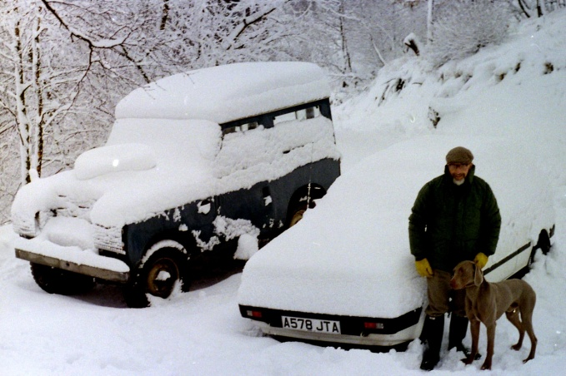 | 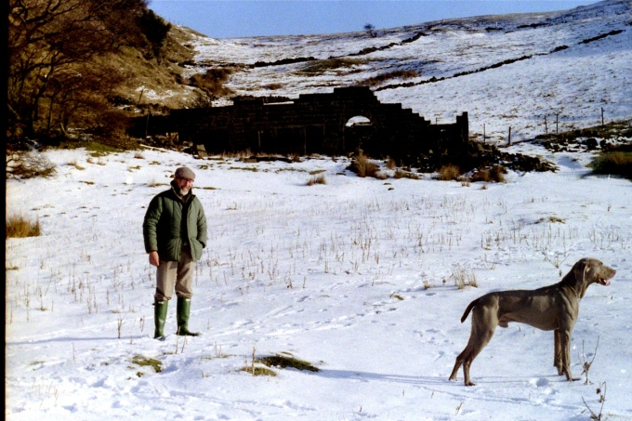
Fred with the cars at the bottom of the drive | Fred with Lance in the field below Shore

Other memorable events in 1984 were the decision to have a vasectomy in March and, more pleasurable a summer holiday in a caravan at Durdle Door Camp visiting mum and dad in South Wales and Mavis at Stoford near Yeovil on the way back. The Landrover’s dynamo gave up on the way back on the A303 but we managed to limp to a local garage who amazingly had a new one which I managed to install and we were back on the road within an hour.

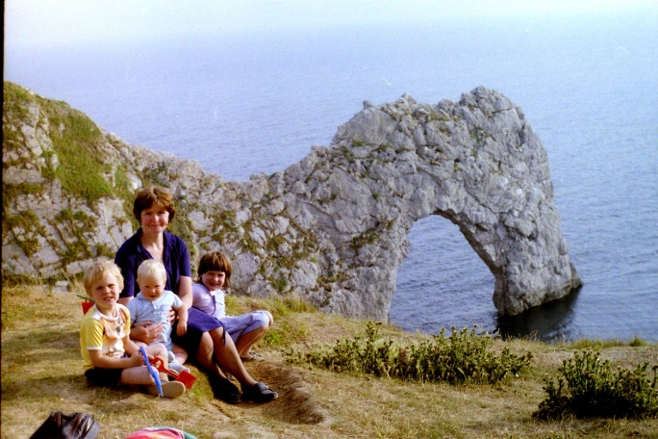 | 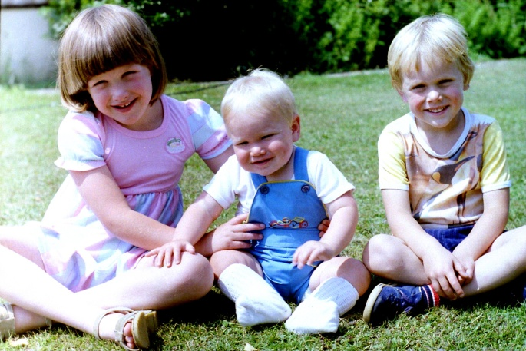
Gill and Kids at Durdle Door | The children 1984

I continued working at City Architects with interesting projects including Shawbrook School for the partial hearing in Withington, Parrs Wood Hostel (for maladjusted children) and a large extension at Oakwood High School near Chorlton with a steady income enabling us to continue with renovation of the cottages and take a caravan holiday in Abersoch, North Wales over summer 1985. This included visits to Portmerion and Harlech and Caernarvon Castles. Due to the workload at City Architects we took on several contract draughtsmen including Chris Charlton and Gareth Roberts who became long term family friends. Marc also started school but Vale School closed down and the children had to move to Robinwood J & I School
In 1986 we returned to Lulworth for our summer holiday and combined this with a visit to mum and dads and Aunty Mavis at Stoford again. Mavis had decided to sell of plots of land which had been part of the market garden business with Fred and I put together an outline planning application for 6 plots. With the proceeds from some of this she decided to replace the old Croft bungalow with a new purpose designed house. She had a fixed idea that this should be hexagonal in plan and that I should design it and over summer most of the old building was demolished leaving only the bathroom standing and she moved into a small caravan on site with me trying to co-ordinate work with her builder from 260 miles away. Chris Charlton and his wife Mary had friends in Dorchester and helped me out with an inspection part way through the work on site on the way to visit their friends.

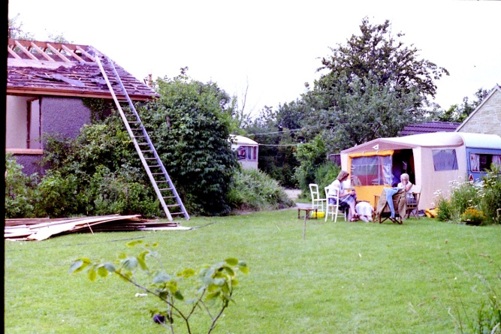 | 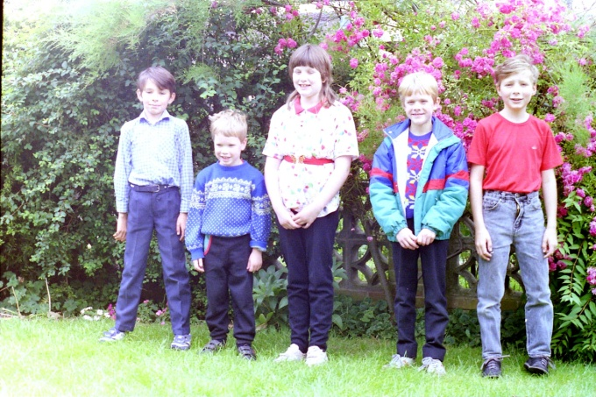
The old Croft under demolition and Mavis’s Caravan | Martin, Anthony, Melissa, Marc and Carl

In 1987 we traded in the old Landrover for a newer version and returned to Abersoch for our summer holiday. We also fitted in a visit to see Mavis move in to her new hexagonal house at The Croft. 1988 included a visit to see Mavis and then over to Arthur and Ann’s in Thatcham calling off at Stonehenge on the way over and trips in to London as an experience with the children. Later in the year Mavis and her sister Babbs came up to stay with us in Todmorden for a few days as part of their coach trip around Yorkshire. Coincidentally I also hit my 40th birthday. Gill also managed to get a job as a Teaching Assistant at Robinwood which was a great boost to family finances. A further addition to our family was 2 kittens Buffy (black and white male) and Candy (tortoise shell female) brother and sister.
By the late 1980s work at City Architect’s had become less interesting. Gareth who had trained with us and qualified as an architect had decided to leave and join the police force in North Wales where his father had served and Chris Charlton left to do contract work in other architectural practices around Manchester. The work for the council had also become more politically involved with me having to present schemes to some very left wing councillors. During this time I kept in touch with Chris Charlton and he advised me that he was enjoying work with a young and growing practice called Leslie Jones Architects and I asked him to see if they were recruiting new staff. This resulted in an interview with one of their associates, Andy Collins and an offer of a job so in September 1989 I took the plunge and after 16 years at City Architects resigned to join Leslie Jones Architects.
1989-2009 Working at Leslie Jones Architects.
The new job at Leslie Jones was challenging and very different from local authority but just what I needed. Initially I had been appointed to work on a refurbishment project on Bury Millgate Centre but this project was delayed and I was asked to work with another architect Collin Birkett on the refurbishment of the Pentagon Centre in Chatham. This involved fortnightly visits to Chatham travelling on the all night sleeper from Manchester to London Euston waking up in the early hours at Euston and then either by Circle Line to Victoria or on foot down Regent Street and across Green Park and then a local train to Chatham. Collin and I found a good cafe called Grandma’s kitchen at Victoria where we got well known as regulars during the job. The partner in charge was a great character called John Watling who was based in the London Office of Leslie Jones who believed in working hard and playing hard and we had some memorable times together including a storm that stranded us all in the partner’s flats behind the London Office at Bentink Street. (1990?). I was also given my first company car in 1990 and we took our first family holiday abroad in Achravi on Corfu thatsummer.
1991 was the year of Mum and Dad’s golden wedding anniversary and in August we all met up in North Wales to celebrate the event. Claire, one of the clerks at LJs had an uncle who had a holiday cottage to let at Dolwyddellyn near Betws-y-Coed and we hired this for an extended weekend. Collin my work colleague also got married to Janet that year and Gill and I were invited to the reception in Cheadle. We also managed a foreign holiday in Pria da Luz in Portugal with a sardine fishing trip and beach barbecue being the highlight from the children’s point of view.

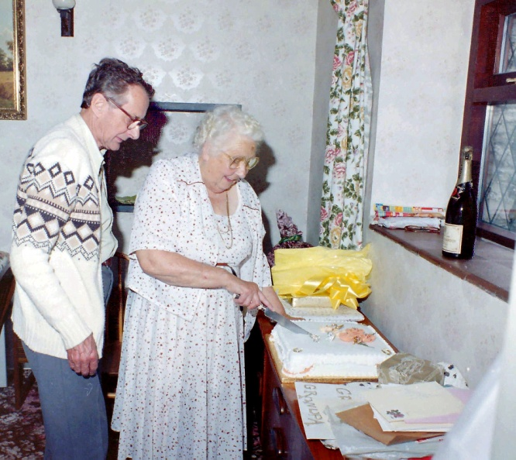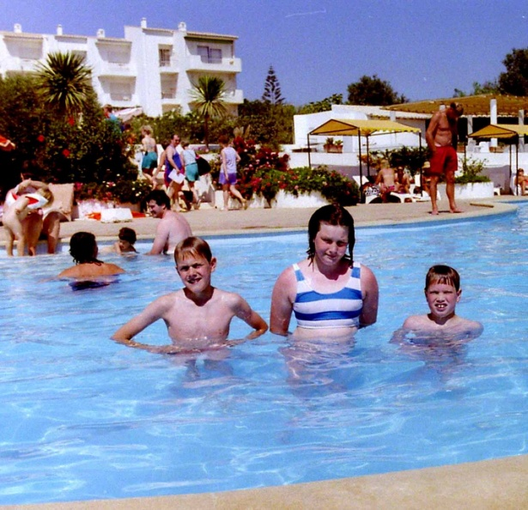
Mum and Dad’s Golden Wedding Pool at Pria da Luz

As work on Chatham progressed I was also asked to take on a lead role on the refurbishment of Riverside Shopping Centre and Pride Hill Centre in Shrewsbury. This was very handy as mum and dad were feeling the effects of old age and mum had a serious heart condition so I was able to travel on down the A49 from Shrewsbury to Hereford and Abergavenny to fit in weekend visits with mileage partly covered as expenses.
In 1992 Mum died of a heart attack. Her love and knowledge of nature and plants is something I will never forget and much has worn off on me. I will also remember fondly the many times she created fantastic meals or made pastry without the need for recipe books or the trays of meringues created as if by magic which were part of my childhood. We decided to miss out on a foreign holiday that year but booked a fortnight in a converted coastguard’s cottage on the river estuary at Polruan in Cornwall so that we could call in on dad on both legs of our journey, The weather wasn’t kind to us and even Cornish ice-cream in Peranporth and the seal sanctuary at Gweek were marred by steady rain.
Work in Shrewsbury progressed well in 1993 and the job was made more enjoyable by some of the characters involved. The structural engineer was an elderly Polish man called Kasic Schmiel and he was incredibly helpful and creative. Higgs and Hill, the main contractors had a young contract manager Richard Vining who was keen to deliver a high quality job and morning site meetings always started with a bacon butty from a bakers we had relocated in the Riverside Centre. For our 1993 summer holiday we booked a fortnight on the island of Aegina accessed by a ferry from Piraeus harbour involving a 40min boat trip. The highlight of the holiday was a trip back into Athens to see the Acropolis in temperatures in the high 30s but we also had boat trips round other nearby islands including the picturesque Hedra where the artist Papas had a studio. Moni island colonised by peacocks and the nearby fishing village of Perdika were also well worth the visit.
We lost Lance at the age of 13 in November 1994. He had been a great character and although he had been very strong willed he loved the children and saw it as his job in life to protect them and our part of the hillside from everyone. Mum had left some money for me in her will and with part of this we had the driveway concreted and a base for a garage formed at the head and I started building retaining walls to the back and side of the garage where it cut into the hill. For our summer break that year we headed for Nerja in southern Spain with trips up to the Alhambra Palace and Grenada and across to Gibraltar.
After over 6 months without a dog we felt it was time to get another and we contacted Patsy Hollins who bred show Weimaraners at Yeadon near Leeds Airport. Coincidentally she had a 3yr old dog which needed re-homing so in 1995 Theo joined our family. He was quite a solidly built dog with a gentle nature and fitted in well with the family including the cats. We also set up a shed and pen with hens and ducks on the terrace above the cottages. Our holiday choice that summer was at Trulos on the island of Skiathos with its beautiful sandy beaches and boat trips to many of the adjoining islands. Towards the end of the year Gill’s mum started to suffer with pains in her neck and was later diagnosed with cancer affecting her lymph glands. In January 1996 Gill’s mum died. She had been a great support to us particularly with the children and our only consolation is that she had a few enjoyable years in Todmorden taking her grand-children on trips to Roundhay Park, Shibden Hall and other local attractions before she started to suffer. We also lost Buffy our black and white male cat who had been a great character to Bartonella Felix a cat disease .
1996 was a busy year both at work and home. I had completed work at Shrewsbury and was well into a design and build refurbishment of Salford Shopping City again with Higgs and Hill. New projects at Livingston Almondvale Centre near Edinburgh and refurbishment of Rochdale Shopping Centre were also on the cards and Leslie Jones were taking on staff to deal with the work load. It was also Dad’s 80th birthday in May and Aunty Mavis’s 70th My sister in law Ann and nephew Martin also had birthdays in May and we all met up at the new hexagonal Croft to celebrate. Our summer holiday was on the island of Thassos near the northern Aegean coast of Greece and the ruins of Phillipi. Melissa at 17 decided to arrange a separate holiday with school friends. There were some great beaches on the island and the local white marble was evident throughout the island. Bees were part of the local economy but did make access to the swimming pool at the apartments hazardous. A small acropolis above Thassos Town provided a great view point over the bay and the Georgie Best’s Bar on the walk up to the top was a welcome attraction for the boys.
The late 1990s was a period when all of the children seemed to grow up quickly and become more independent. In 1997 we got an RSPCA rescue cat Basil another black and white male who proved to be an amusing and very affectionate cat, we spent our summer holiday on the island of Zante with Marc and Anthony having a separate apartment and a highlight of the holiday was hire of an open jeep to tour the small island. Work up in Livingston also involved me in regular flights up to Edinburgh to supervise both the initial Safeway supermarket and adjoining groundworks and then the main shopping centre. We also carried out significant refurbishment of the old Almondvale Centre for Landsecurities. I was invited over to a stone products exhibition (by the Spanish promoters) in Barcelona that autumn and developed a love for that city. Part of the visit involved a trip to a Spanish concrete casting company “Pujol” who cast the beams for extending the Nu Camp Stadium where the pitch was lowered to accommodate 6 more tiers of seating over a summer holiday period of 8 weeks.
I had been given a series of company cars by LJs but in 1998 decided that the tax advantages were not sufficient and I bought our own VW Passat. In summer Aunty Mavis also decided to renew her Nissan Micra and offered us her old one for the children at a very competitive rate so Melissa and I caught the train down to Yeovil and Mel. drove us back in the Micra via south Wales to visit dad.. The boys also decided that they were too old to come on holiday with us so we decided to forego a foreign holiday that year and hired a cottage in Poolewe at the mouth of Loch Ewe for our summer holiday. It was magnificent scenery but the weather was typically Scottish and the midges particularly around Poolewe Gardens were horrific. The local pubs also took last orders at 8.00 pm. so evening meals were hard to get. We also had a pleasant long weekend in Barcelona with friends Jean and Nigel Cuffin who I had got to know through work.
By 1999 work in Livingston was coming to an end and I had been asked to take on another project at Great Northern Warehouse in Manchester converting the Grade II listed railway warehouse, creating a new public amphitheatre to the front with bars and restaurants and building a new 16 screen cinema complex for AMC to the rear in the area of the old railway marshalling yard. This was a huge project worth over £50m in 2 phases and quite a challenge. I was also still trying to complete work at Rochdale Shopping Centre in time for the 150th anniversary of the Co-operative Pioneer’s movement for the main client CIS. It was also the year of Melissa’s 21st Birthday so time to celebrate though her boyfriend John King was now involving a lot of her time. Gill and I managed a holiday in Tolon on mainland Greece over summer which gave us access to the Corinth Canal the remains of Mycenae and Olympia.
Apart from being the millennium the year 2000 was marked by Melissa getting her degree in Psychology at Bradford University. Marc had left school to start a catering course at Hopwood Hall near Rochdale and had now secured a place on a degree course at Blackpool and Fylde College in hospitality and catering. Gill and I booked a summer holiday on the Island of Samos which unfortunately was affected by a number of fires that year but we did get a trip over to nearby Turkey to see the ruins and library at Ephesus. Dad was evidently not coping mentally and after a stay with Arthur and Ann over Christmas we agreed that it would be better to find him accommodation nearer to Arthur who found a flat in Thatcham and we put his house in South Wales up for sale. I had several trips down with the unpleasant task of clearing out years of our parents belongings and we hired a van to transport dad’s main furniture into his new flat.
In 2001 dad continued to decline and eventually had to move into a care home near Froxfield where he could have greater care. I managed to transport some of his old furniture up to Todmorden in the back of the Passat. Meanwhile work on Great Northern was progressing but a source of constant stress due to the scale and pace of the project. Over summer Gill and I had a much needed holiday in Parga on mainland Greece, a place we instantly fell in love with. Walks through olive groves over to Lichnos beach, walking up the river gorge at Glikki, a boat trip out to the islands of Paxos and Antipaxos and a trip to the monasteries at Meteora made this a trip to remember.
In 2002 dad fell over at his nursing home and broke his hip, following this he developed pneumonia and sadly in February he died in hospital at Swindon. He had always been a fairly reserved man but had a strength and intelligence which the family will always miss. Not long after this we took Theo for a walk along Bluebell Lane above Shore. He seemed to become ill not long after the walk and we rushed him to the vet who said he had serious kidney failure and recommended immediate euthanasia. We believe he had drunk water on the track which contained antifreeze. Not a good start to the year! For his years practical training Marc managed to find employment at Disney in Florida and it was a strange feeling waving him off at the airport for a year away from home.

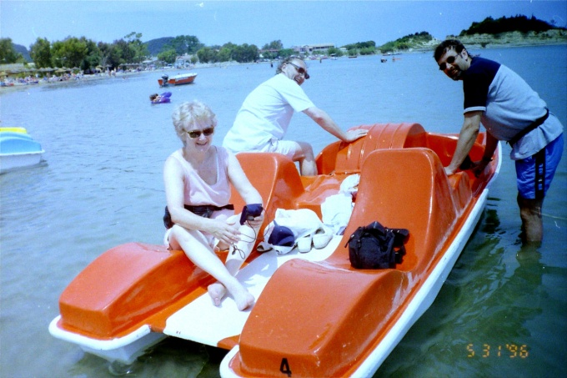 | 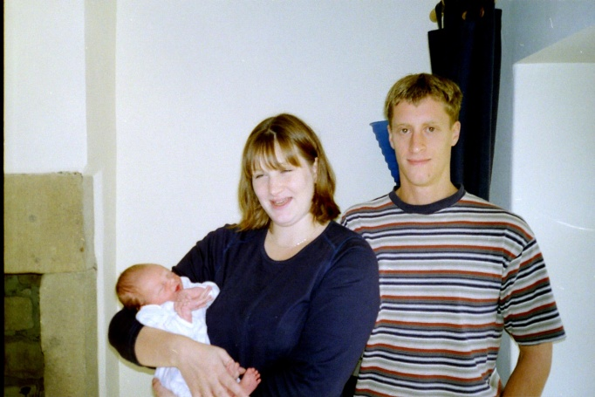
Jean and Nigel at Sidari | Melissa, John and Elliot

We planned a early holiday in Paleokastrisa on Corfu with our friends Jean and Nigel and had a good break there hiring a car to see other parts of the island including Sidari where we had a memorable trip round the bay by pedalo. It was the year of the World Cup and Nigel was a football fanatic and anxious not to hear results before he could watch each match. Early in the year we also found out that Melissa was pregnant. She and John had bought a small terraced property at Calderside near Hebden Bridge and in September our first grandchild Elliot was born. With some of the money dad had left me I also traded in the VW Passat for a new Audi Avant, the first new car I had ever owned. Towards the end of the year I was also missing my Weimaraner and we rang Patsy Hollins again with the inevitable result that she had a 4yr old rescue dog and Pluto joined the family.
By the end of 2002 Gill’s dad had started to suffer and support was needed not only from Gill but care workers with Gill walking down to Church Street nearly every day to help him and us both dropping in as often as possible. In 2003 we called the doctor in and he was taken into Halifax hospital and died shortly afterwards with cancer of the liver. His help with the cottage and his ready welcome with a bacon butty cooked in the Aga at Church Street will always be missed. Work on Great Northern was also coming to an end though there was still involvement with new tenant requirements including a new casino in the warehouse which involved changes to the completed scheme. I was also asked to lead a team working on Piccadilly Plaza in Manchester which involved re-building of former office space for a David Lloyd Leisure Centre, A suite of offices for courts for the Immigration Authority and potential renovation of the Piccadily Hotel tower. We succeeded in completing the work for the Immigration Authority and the shell works for David Lloyd but the health centre was never fitted out and the remains of the project struggled through lack of finance.
Over Easter 2003 we had a trip to Sorrento with trips up Vesuvius and to see Pompeii and a tour down the Amalfi Coast and over to Capri. During our break John and his dad fitted a new bathroom for us, a great improvement on the original I had put in back in 1978. Later that year we also got them to replace the roof to the cottage with look-a-like stone flags. This included new rafters with insulation between. At work I was also asked to take on a project at the Designer Outlet at Fleetwood demolishing part of the old centre and creating space for M&S and River Island along with a series of smaller units. Over summer Gill and I had booked a holiday in the Pelion in northern Greece and had a great holiday travelling on the little mountain railway from Kala Nera up to some of the hillside villages with their ancient plane trees as well as a boat trip round the Pagasitic Gulf and down the east coast to Skiathos
2004 was another eventful year with Melissa giving birth to our second grand-child Eloise in July. This coincided with John completing work on building their new house at Higher Underbank on the hillside above Hebden Bridge, they moved in the day before Eloise was born and Melissa was back home cooking breakfast 24hrs after the event. We had also planned an Easter break flying out for 3 days in Venice and then catching the Euro-star down to Rome for a further 4 days and flight back directly from Rome. It was a wonderful trip but we should have done it the other way round as the chaos of Rome with its traffic and noise was a complete contrast to the peace and tranquillity of Venice. Marc also gained his degree in Hospitality and Catering at Blackpool and was awarded the LETTS student of the year award at the same time. For summer we had another Greek holiday with 10 days on the island of Crete near Hannia. We hired a car to drive up into the White Mountains and had essential trips to the ruins at Knossos and a walk through a dynamic gorge through the White mountains as well as spending several sun filled days by the pool or on local beaches.
Work at Leslie Jones’s had become less of a pressure by 2005 and I was asked to take on the refurbishment of the Designer Outlet Centre at Fleetwood, putting in a new M&S store an extended River Island with a range of new shops and a cafe. We also had two holidays with an Easter trip to Malcesine on Lake Garda and a week in Tenerife in October both providing enjoyable breaks. Sadly Pluto developed a strangulated bowel and despite an operation did not recover.
On 11th June 2005 Melissa and John got married up at Heptonstall. Fortunately the weather was fine and it turned out to be a wonderful family day.
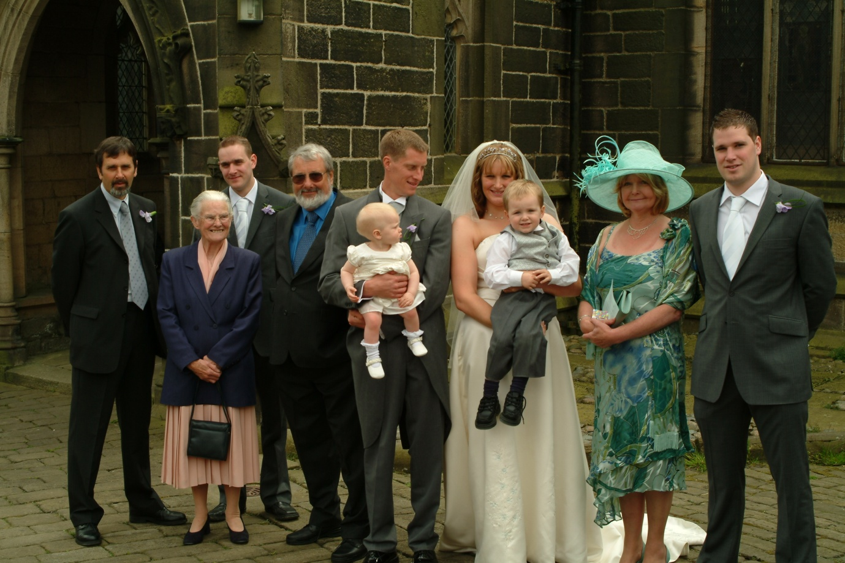
Left to Right.Me, Mavis, Marc, Arthur, John and Eloise, Melissa and Elliot Gill and Anthony

In 2006 the Manchester Office of Leslie Jones ran with Modus Developments in a competition for the redevelopment of Newport Town Centre in South Wales, which was part of my childhood territory and we were fortunately successful as part of the winning team. I was asked to run as the Associate in charge of the project and we built up a strong team of staff and contract draughtsmen to develop the ideas. Initially this went well involving trips to key tenants including M&S and Debenhams as well as a whole host of smaller high street names. The turning point in the project came with the decision to involve the London Office of Leslie Jones where most of the Partners were based and whose decisions could not be over-ruled. Brian Tracy was appointed as Partner in charge and he immediately had an impact on the project changing many of the design decisions which had already been taken and were in development. He also arrange to change the structural engineers to a London office of the same practice where he had previous contacts and relationships built with their Manchester office were immediately lost.
During the summer of 2006 we had a holiday in Stoupa in the Peloponnese with visits to Mistra, an early Byzantine settlement and a trip through the mainland to Sparta. The resort was excellent but isolated by distance down one of the 5 peninsulas. By the end of the year I had also decided that I needed another dog and we bought an 8 week old Weimaraner pup Oscar from a local kennels near Blackburn and he soon became an essential part of the family life.
Over 2007 work on Newport became ever more difficult with London Office taking over more elements of the design so that it was impossible to progress logically on any part. In April Melissa gave birth to our 3rd grand-child Aidan, who although born with some learning difficulties has become quite a sociable and loving character. We traded in the Audi Avant for a new Audi A3 Sport and booked 2 holidays, the first at Easter with our friends Jean and Nigel with 4 days in Venice and then a trip on the Eurostar down to Florence for a further 3 days. For the autumn break Gill and I had a week in Alcudia in Majorca and although the weather was fine it had turned too cold for swimming or enjoying the beach.
2008 turned out to be a relatively quite year with funding for the project in Newport looking more questionable. We booked a fortnight’s summer holiday back in Parga at our favourite hotel Resi and a further Autumn break for a week in Porto Mogan in Gran Canaria.
2009 turned out to be a turning point in our lives with the world recession affecting funding for the project in Newport and much of our other workload on retail projects. In April I firstly had to say goodbye to my team who were all made redundant and then I was finally made redundant at the end of May. Eventually the Manchester office of Leslie Jones closed down and all of the residual work was taken down to the London Office. Faced with redundancy at 62 with most other architectural practices also laying off staff It became obvious that I would not find another job and I took the decision to take my redundancy money to set up my own practice working from a spare bedroom at home. Initially I was very fortunate in finding work as the partner in charge at Leslie Jones (Andrew Ogg) had a brother who was owner and MD of a company based in Rotherham called History and Heraldry and who was looking for an architect to sort out problems he had with a planning refusal to extend his warehouse on the Hellaby Estate. Andrew put me in touch with him and after an initial meeting with the local planners I found a way forward with a revised scheme which rapidly progressed from planning to construction. I was subsequently asked to look at work on their adjoining business Paper Island which again progressed to construction on site. On the back of these projects I was also invited to carry out work on another warehouse on the same industrial estate for Pyronix who manufactured and sold fire alarm equipment. Gill had also been spending quite a lot of time helping to look after Marc’s rescue Greyhound April based at 6 Church Street and the decision was taken that she would be better off living with us full time due to Marc’s work-load. Fortunately Oscar accepted this arrangement and the two dogs seemed to get on well together.
In 2010 I was also invited to look at a new warehouse extension for Stephenson’s Animal feeds at Robinwood Mill in Todmorden. As a long term customer I had jokingly told Claire Stephenson, one of the owners, that they would need to drop their prices on animal feeds as I had been made redundant. They had been having difficulties with a local architect making progress on the project and after the necessary correspondence I took over the project and again saw this through Planning, Building Regulations and Construction with the help of one of my former colleagues Dave Barton. With the confidence of income from my work we booked another summer holiday and enjoyed a fortnight in our favourite resort in Parga. Melissa also gave birth to our fourth grandchild Samuel in August who has subsequently turned out to be a very robust and self contained little boy. Sadly early in the year Basil our lovely old black and white cat suffered liver failure and we had to say goodbye to him.
2011 (end of May) was the year of Gill’s 60th birthday and fortunately I had enough confidence in my income to book a four day break in Paris for the occasion. Luckily the weather was brilliant and we had a great time wandering the streets around Mont Martre, visiting the local markets, the Louvre and Eifel Tower. Our hotel was luxurious, close to the Champs Elise and L Arc de Triomphe. I also decided to spend the rest of my redundancy money in building a new office off the gable end of our house. Very fortunately Robinwood Mill the site of Stephenson’s animal feeds had an old mill pond which had been filled with demolition stone and rubble back in the 1980s. Co-incidentally they were clearing this out at the time and I had an agreement that I could take as much facing stone as I could salvage and carry away for £200. With the help of John’s nephew Daniel who could operate the JCB on site and had a Landrover and trailer we brought back over 10 tonnes of stone which took me another 6 weeks to back off for cavity construction. I also hand dug the foundations and brought blockwork up to ground level with an agreement with John that he would complete the work above ground. We were also offered another neutered Tom-cat Leo by a local girl Hanna Merriman who had two other cats and was looking to re-home Leo so we acquired a further addition to the family. In August Melissa gave birth to our fourth grand-child Sam, a robust and health lad who has since turned out to be an intelligent happy and self contained child. We also booked a late summer break in Menorca. The hotel was a gold standard, adults only resort and the food was ridiculously lavish with many of the guests overweight and hardly moving from the dining area. Marc also moved job to manage a hotel “The Greyhound” near Aldershot. It seemed like a good move and promotion at the time but in hindsight did not turn out that way.
2012 was a relatively quiet year with me moving into the new office and more new work on an Abbeyfield Home extension up in Whitehaven. We also put the house at Church Street up for sale and accepted an offer of over £90K which was a great return on our original purchase. For summer we managed another trip to Parga at our favourite Hotel Resi.
By 2013 the isolation away from friends and family and the pressure of his job became too much for Marc and it was also evident that he was drinking heavily so that eventually he decided to pack in the job and return home. I called in at Arthur and Ann’s on the way down to pick him up but he insisted on driving back following me slowly. He made it all the way back but then collapsed sitting in the car at the head of the drive till we eventually managed to get him inside and stable. Later in the year he fell down stairs resulting in a broken bone in his neck, trips to hospital wearing a neck collar for several weeks and the local substance abuse clinic at Halifax. We managed a holiday in Kitzbuhl in Austria over summer though we were apprehensive about leaving Marc at home on his own. In November a long term life insurance policy I had held matured and I upgraded the Audi A3 Sports for a new model.
2014 improved with Marc concentrating on training for a new job with KFC. He seemed well focused with regular meetings with the training staff and eventually secured a job as assistant manager at a KFC outlet near Bury centre. He got on well with his manager and other staff and seemed relatively happy in his job. We booked another holiday in Parga for the summer at our favourite hotel and were happy to leave Marc to look after the dogs and poultry. Unfortunately on our return we found Marc with two badly bruised eyes from a fall down steps and a suspicion as to the cause.
By 2015 Marc had moved jobs to a KFC just off the M65 near Blackburn and he seemed happy and stable though he had started a relationship with one of the waitresses at the store whose marriage was reportedly failing. He seemed keen to buy a house and after a long search found a 2 bedroom semi in Padiham with a small garden in easy access for his work. In spring I developed a skin condition which resulted in intensive itching particularly on my legs. After many mis-diagnoses including fungal infection, scabies and bullous pemphigoid the specialist settled on discoid eczema and although not cured the ointments prescribed have since gone some way to relieve the condition. Over Easter we booked a short break in Bruges flying to Brussels and then by train into Bruges. It was a good break and the weather was fine during our stay but we had to come to terms with all restaurants closing by 9.00pm and little to do after that time. Marc exchanged contracts on the house in Padiham shortly after his 35th birthday on 13th June and moved in shortly after. We had hoped this would be the making of him but he rapidly became less sociable and obviously had started drinking again. On 13th July we had the old gas boiler repaced by British Gas. On 14th July, having had no reply on his mobile over the last few days we decided to call round to see Marc. I will never forget that day as I had to break in and found Marc lying dead on his bed. After the initial shock both for me and Gill we called for help and eventually had to drive back home in a daze to inform the rest of the family. The rest of that year was a nightmare waiting for the Coroner’s report, trips to the Registry Office, organising the funeral and eventually selling the house, his car and dealing with banks, phone agreements and insurance companies. Despite the last few years of stress we will always miss Marc a much loved eldest son who had so much potential sadly unrealised.
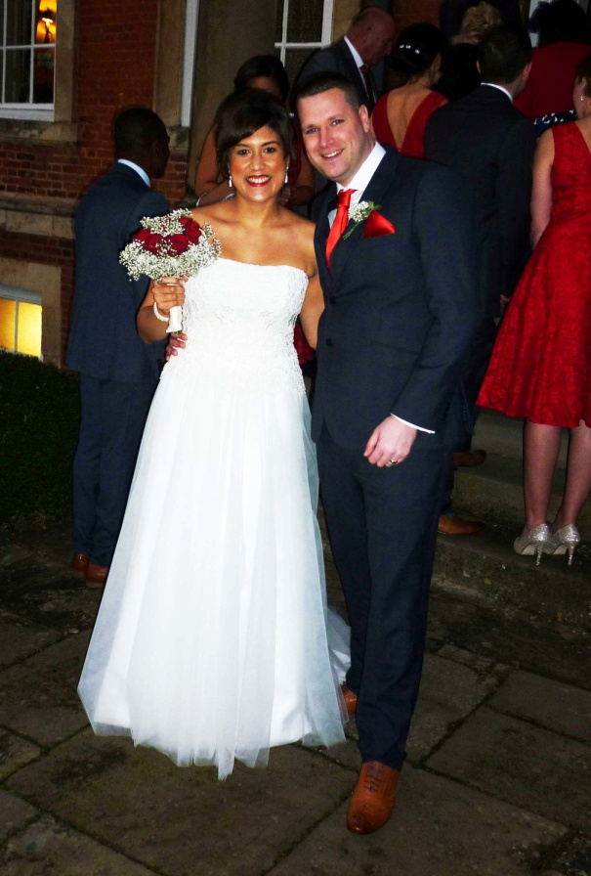 | 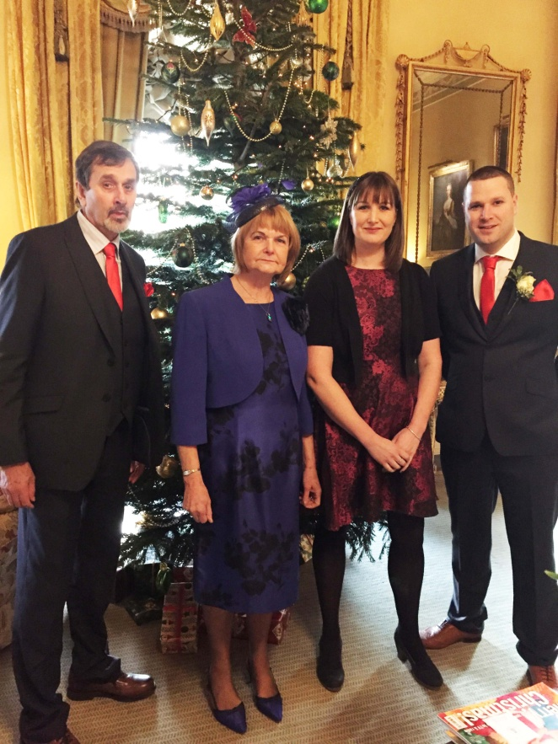
Anthony & Gemma December 2016 | Me, Gill, Melissa and Anthony

Through 2016 I continued to work on major projects at Hollins Mill (conversion for 13 flats) and Portsmouth Mill converting the mill for 10 new flats and 12 additional houses. We also managed another summer trip to Parga. Anthony and Gemma decided that they would get married over the Christmas break on 28th December with the ceremony being held in a luxurious hotel Middlethorpe Hall, near York. It was an enjoyable event particularly after some of our hard times and the weather remained crisp and dry. The drive home next day through misty countryside with trees sparkling with frost and early morning sun was spectacular.
2017 was another relatively quiet year. We took a long weekend break in Venice in May to coincide with Gill’s birthday. In late summer we had a trip to Madeira staying 2 miles from Funchal. It is a beautiful island with wild flowers and incredible scenery with the mountain topped gardens accessed by cable car above Funchal providing an incredible variety of plants. In November I celebrated my 70th birthday with a meal at the Staff of Life pub with the whole family. I also upgraded my car for a new Audi Q2, selling my old Audi to Anthony who had been having trouble with his older 2 seater Audi.
In 2018 we decided to build a new kitchen extension off the porch and eastern gable of the house so early in the year I submitted a planning application and prepared Building Regulation drawings with the help of my old colleague Dave Barton. We booked a holiday in Mlini Croatia just south of Dubrovnik for August and I agreed with John (Son-in Law) that he would dig out the hillside before summer and whilst he, Melissa and family went off to Lake Garda for the summer I would build the 2.5m high dry stone retaining wall to the back of the kitchen site. I also built a new 10m long retaining wall in front of the kitchen site so that spoil could be used as backfill to create a level area and working space to the front. As part of this work we also had a large Cypress tree professionally felled for safety and to improve the view to the front of the kitchen. I was lucky again to source large sections of stone for the retaining wall from work at Portsmouth Mill where the owner (Andrew Brown of N&R) let me take as much as I could for free. John was as good as his word and left me with a level site and large pile of stone before the summer break. Luckily the weather was hot and dry and in 6 weeks I completed the dry stone wall by the time he and his mate Dan returned to start building. By the time Gill and I returned from holiday block walls were substantially built and stonework was progressing. By Christmas the shell of the extension was complete awaiting fit out and finishes and I was progressing with painting and decorating. We celebrated Christmas with a table temporarily set out in the kitchen and friends and family up for various meals. Sadly over summer April, Marc’s old rescue Greyhound suffered from collapsing back legs and eventually problems with her bowels and we had to take the hard decision to put her to sleep. She had been a wonderful, gentle and humorous character and will always be fondly remembered.
2019 saw completion of the kitchen with Italian units fitted by Vama of Luddenden Foot and Gill also bought a new pine dining table. We employed a local tiler to tile the floors throughout and tile the shower and toilet. I continued with fitting out the toilet and cupboards to cover the new plumbing runs in the porch. In March we decided to get another rescue Greyhound and after an unhelpful visit by a member of Lancashire Greyhound Rescue who felt we were unsuitable to home one of their dogs decided to drive over to Tias near Doncaster. They had over 80 dogs and bitches to chose from and we fell for a 3yr old brindle bitch who we subsequently named Freya as storm Freya descended on us as we drove home with her. In late spring Gill and I took Oscar and Freya for an evening walk over the local fields. The grass was damp after recent rain and Gill slipped crying out with pain from her ankle. Initially we thought it was a simple sprain but she could not move and I had to leave her to take the dogs home and call for help. Luckily neighbours Sue and Steve also came across the field and we managed to call in Mountain Rescue who carried her down to a waiting ambulance at the bottom of Frieldhurst Road. Halifax A&E rapidly diagnosed a double fracture and early next day Gill had an operation to plate and reset her ankle. It was very fortunate that we had a new ground floor toilet and shower for gill to use when she came home in plaster and on crutches. We had booked another Croatian holiday for summer in Porec (Istria) and were apprehensive that Gill would not be able to make it but fortunately she recovered quickly and the level costal walks and easy poolside access from our hotel were ideal and we had a great holiday. In December Oscar sadly started to decline with failng back legs and sickness and once again we had to take the hard decision to put him to sleep. I fear he will be the last of my Weimaraners and though a strong willed dog was my great friend and companion for 12 years.
2020 has been a most unusual year. I started writing this document in early February but shortly after the impact of the Covid pandemic struck and all of our lives changed. The one happy event of the year was the birth of Henry. Anthony and Gemma had been going through IVF treatment for some time and had given up the hopes of a family when to their surprise they found that Gemma was pregnant. In the midst of the first wave of the virus on April 13th Henry was born. We haven’t been able to see much of him though we have met up at various outside venues and they have brought him up to see us when restrictions allowed. He seems to be one of the happiest babies ever and is loved by his parents and whole family. I continued working on various small scale architectural projects and also tried to complete paving around the kitchen and surfacing to the extended driveway. I also started to adapt the back bedroom ready to house a new header tank for the solid fuel Wamsler boiler so that this could be re-plumbed to run independently from the central heating. Our panned summer holiday to Zadar in Croatia was cancelled due to the virus. By the end of August I was starting to experience difficulty in swallowing and was frequently sick. It took me 2 weeks to get an appointment with a doctor but after a referral to the Upper GI unit in Huddersfield I was rapidly examined with an endoscopic survey and diagnosed with cancer of the oesophagus. Soon after I was admitted and fitted with a nasal feeding tube and after several detailed CT and PET scans was advised that the cancer had not spread. I was then fitted with a catheter (PIC line) and prescribed a 9 week course of Chemotherapy. This has had some success in shrinking the tumour so that I was again able to swallow and have the nasal feed removed.
The next stage is major surgery to remove the cancer on 21st January 2021. I am advised that this has a 95% success rate and have no option but to accept these odds.

